**Assignment 1. User Creation and Roles: screen shots with steps**

Data added for better understanding.

Use db1

Collection1:

db.table1.insertMany([

{ "_id" : 1, "name" : "Ajay", "status": "active", "level": 9,"score":99},

{ "_id" : 2, "name" : "Priya", "status": "inactive", "level": 5,"score":88}

])

Collection2:

db.table2.insertMany([

{ "_id" : 1, "name" : "Ashish", "status": "active", "level": 10,"score":100},

{ "_id" : 2, "name" : "Santwana", "status": "inactive", "level": 8,"score":50}

])

Use db2

Collection1:

db.table3.insertMany([

{ "_id" : 1, "name" : "Amruta", "status": "active", "level": 1,"score":40},

{ "_id" : 2, "name" : "Avadhoot", "status": "inactive", "level": 4,"score":60}

])

Collection2:

db.table4.insertMany([

{ "_id" : 1, "name" : "Vaishnavi", "status": "active", "level": 8,"score":8},

{ "_id" : 2, "name" : "Abhishek", "status": "inactive", "level": 8,"score":9}

])

Data before adding new Users:

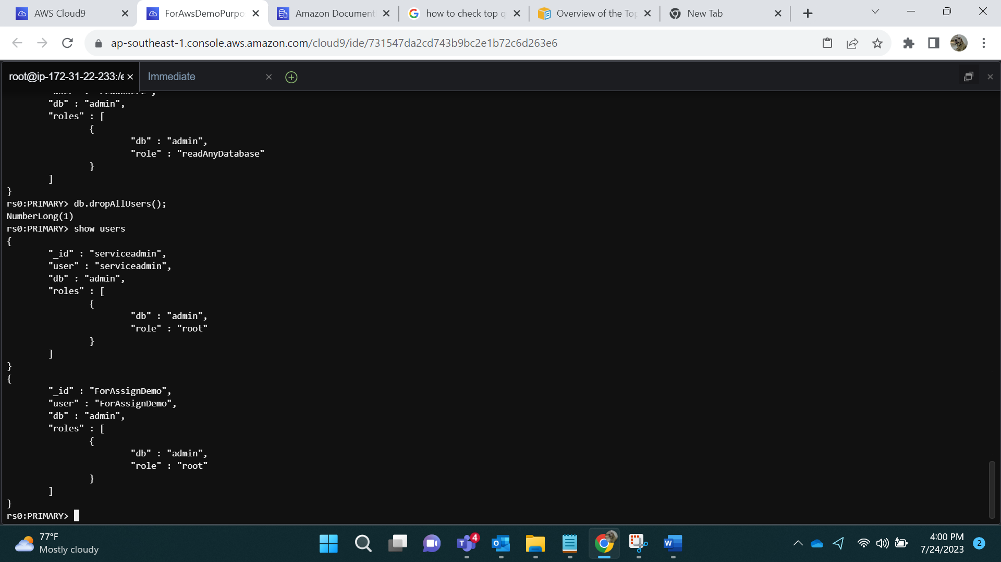

There are only 2 Users present

**- Create a user with read access for the database DB1**

db.createUser({

user: "readUser1",

pwd: "a@1",

roles: [ { role: "read", db: "db1" } ]

});

**Show users**:

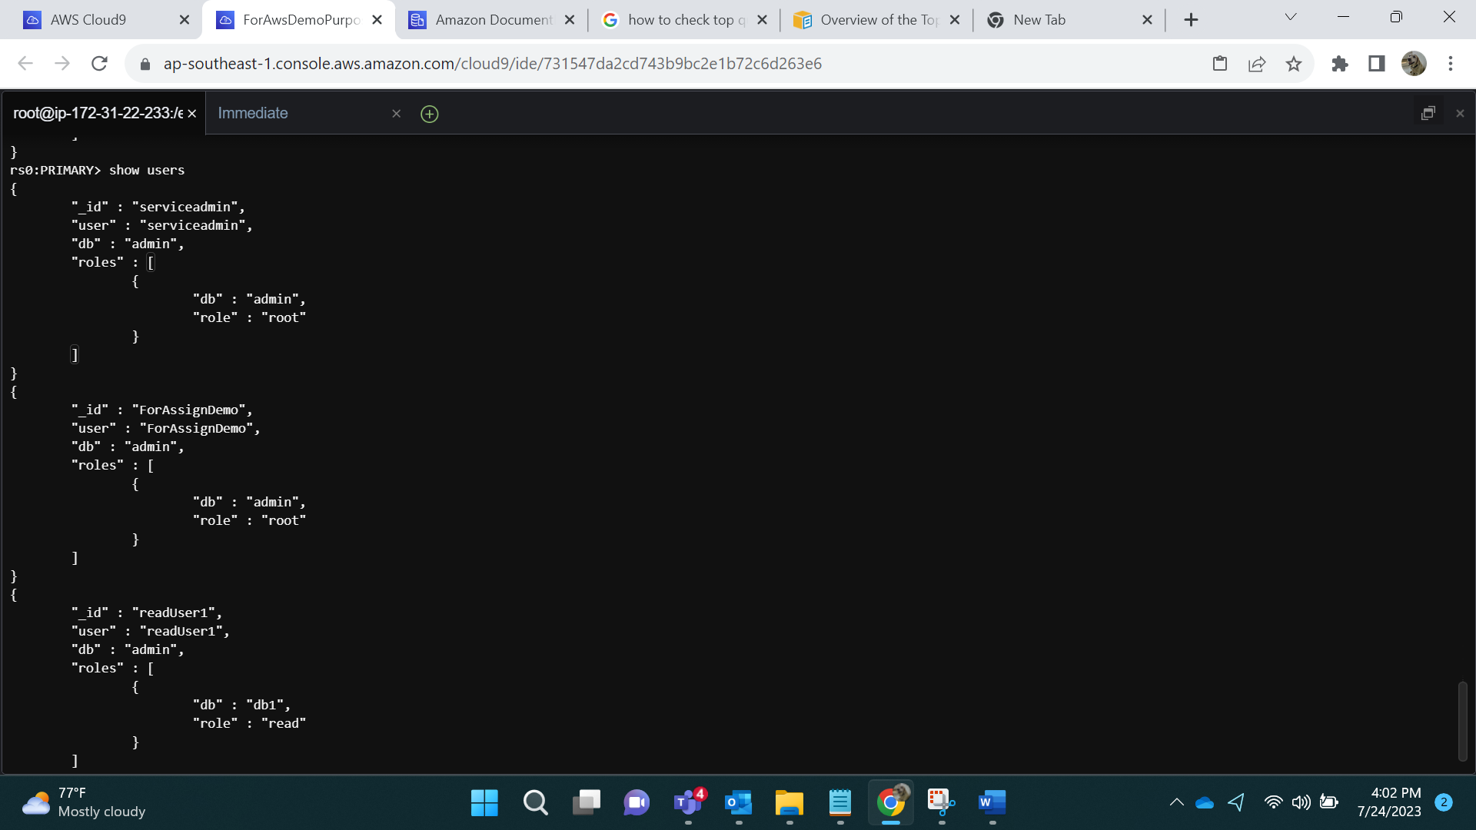

Result: How Output looks for **Admin**:

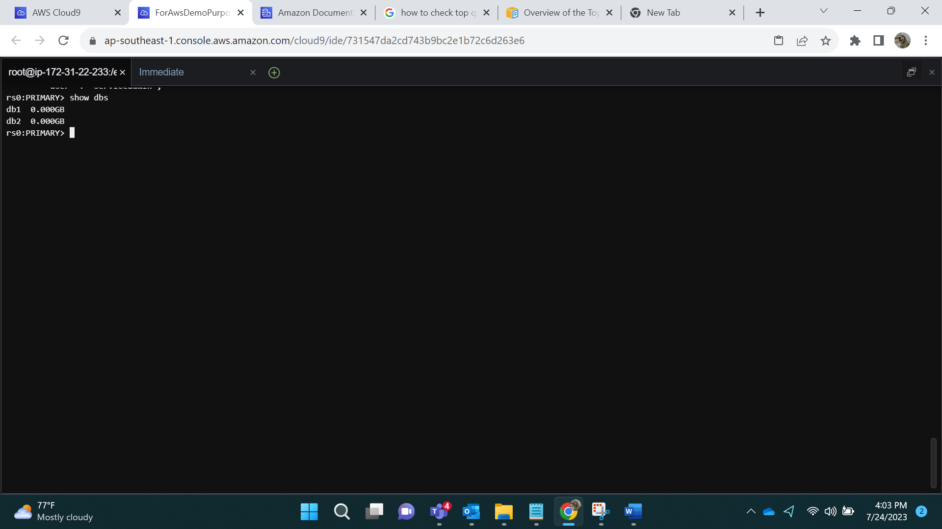

Admin can see db1 and db2.

Logging in via readUser1:

mongo --ssl --host forassin2first.cluster-cia4bvgv8e4r.ap-southeast-1.docdb.amazonaws.com:27017 --sslCAFile global-bundle.pem --username readUser1 --password a@1

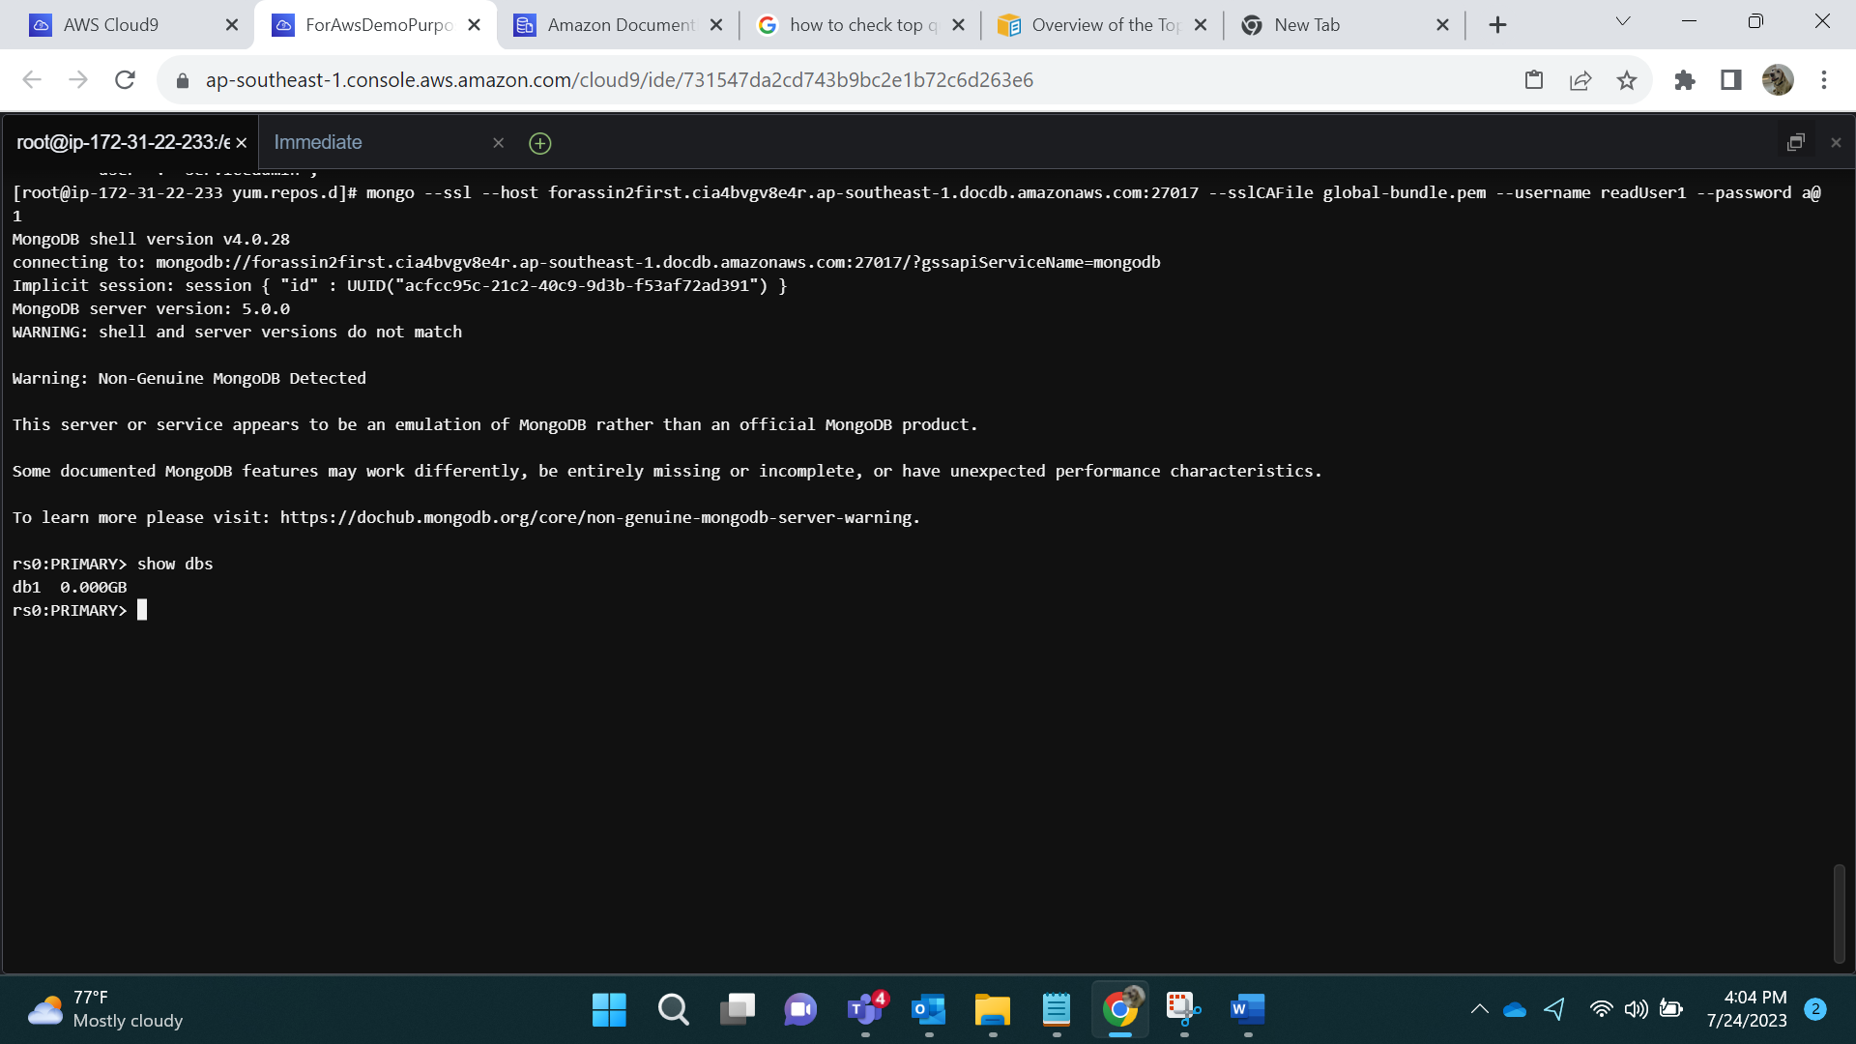

**As we can observe, readUser1 can only see db1 since we have given him only access to db1.**

**- Create a user with read access on all databases.**

db.createUser({

user: "readUser2",

pwd: "b@2",

roles: [ { role: "readAnyDatabase", db: "admin" } ]

});

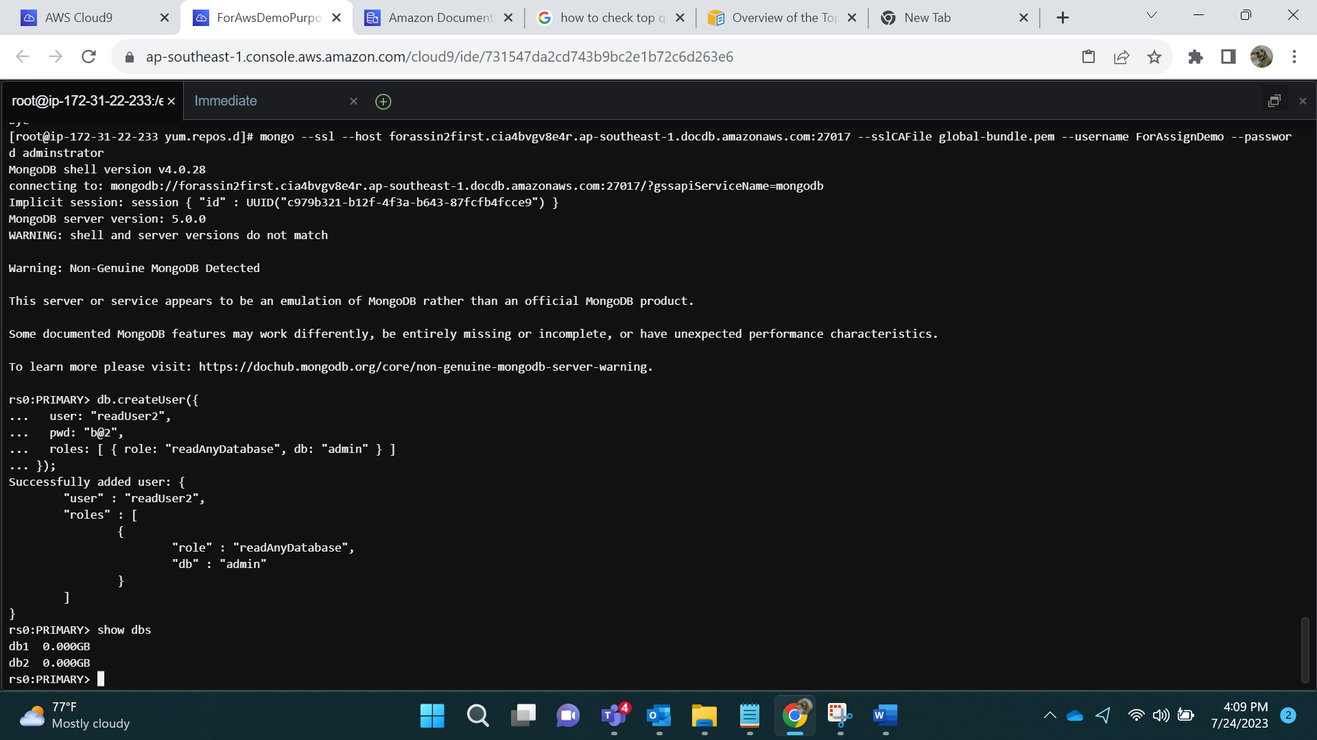

We can also see that admin can see both databases.

Show user:

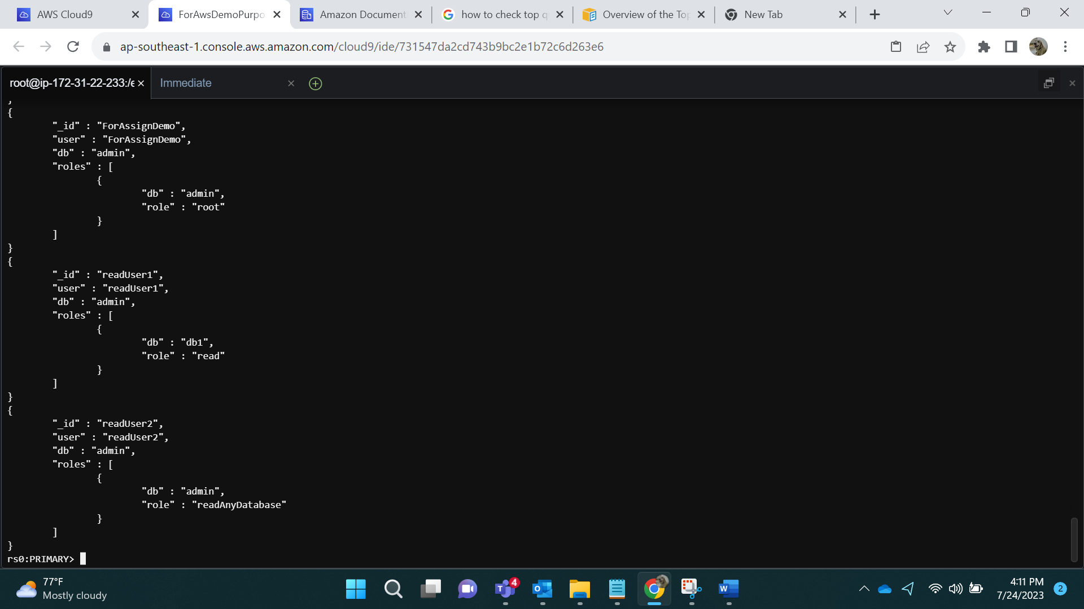

Logging in as readUser2:

mongo --ssl --host forassin2first.cluster-cia4bvgv8e4r.ap-southeast-1.docdb.amazonaws.com:27017 --sslCAFile global-bundle.pem --username readUser2 --password b@2

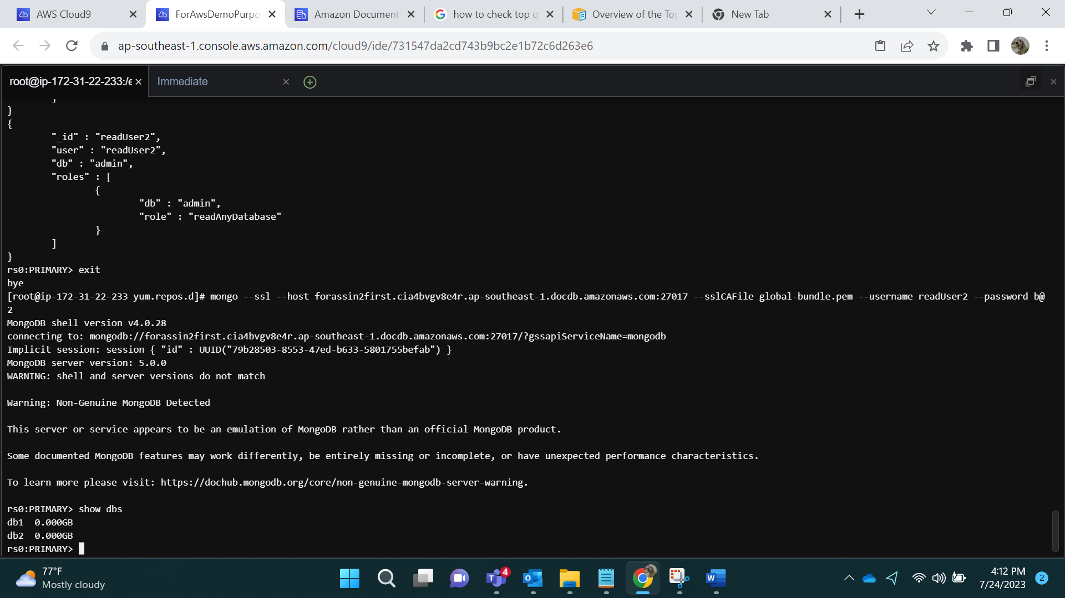

**- create a user with read and write access to DB1 database**

db.createUser({

user: "UserRW1",

pwd: "c@3",

roles: [ { role: "readWrite", db: "db1" } ]

});

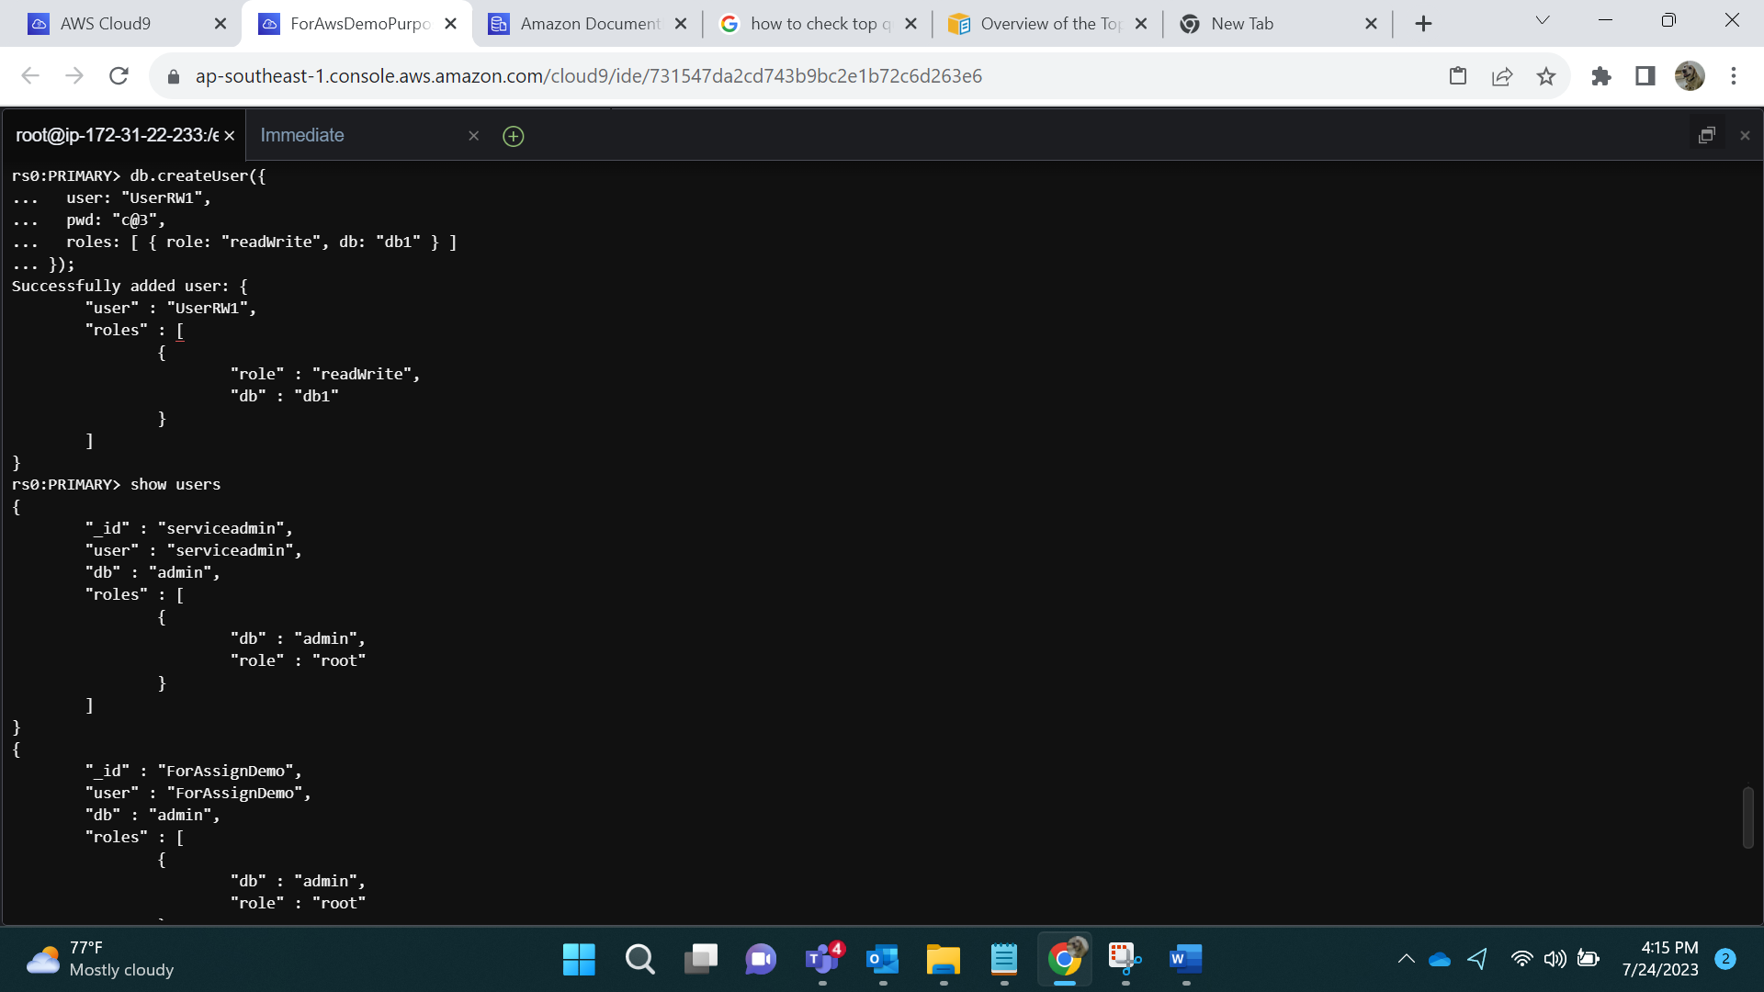

Show users:

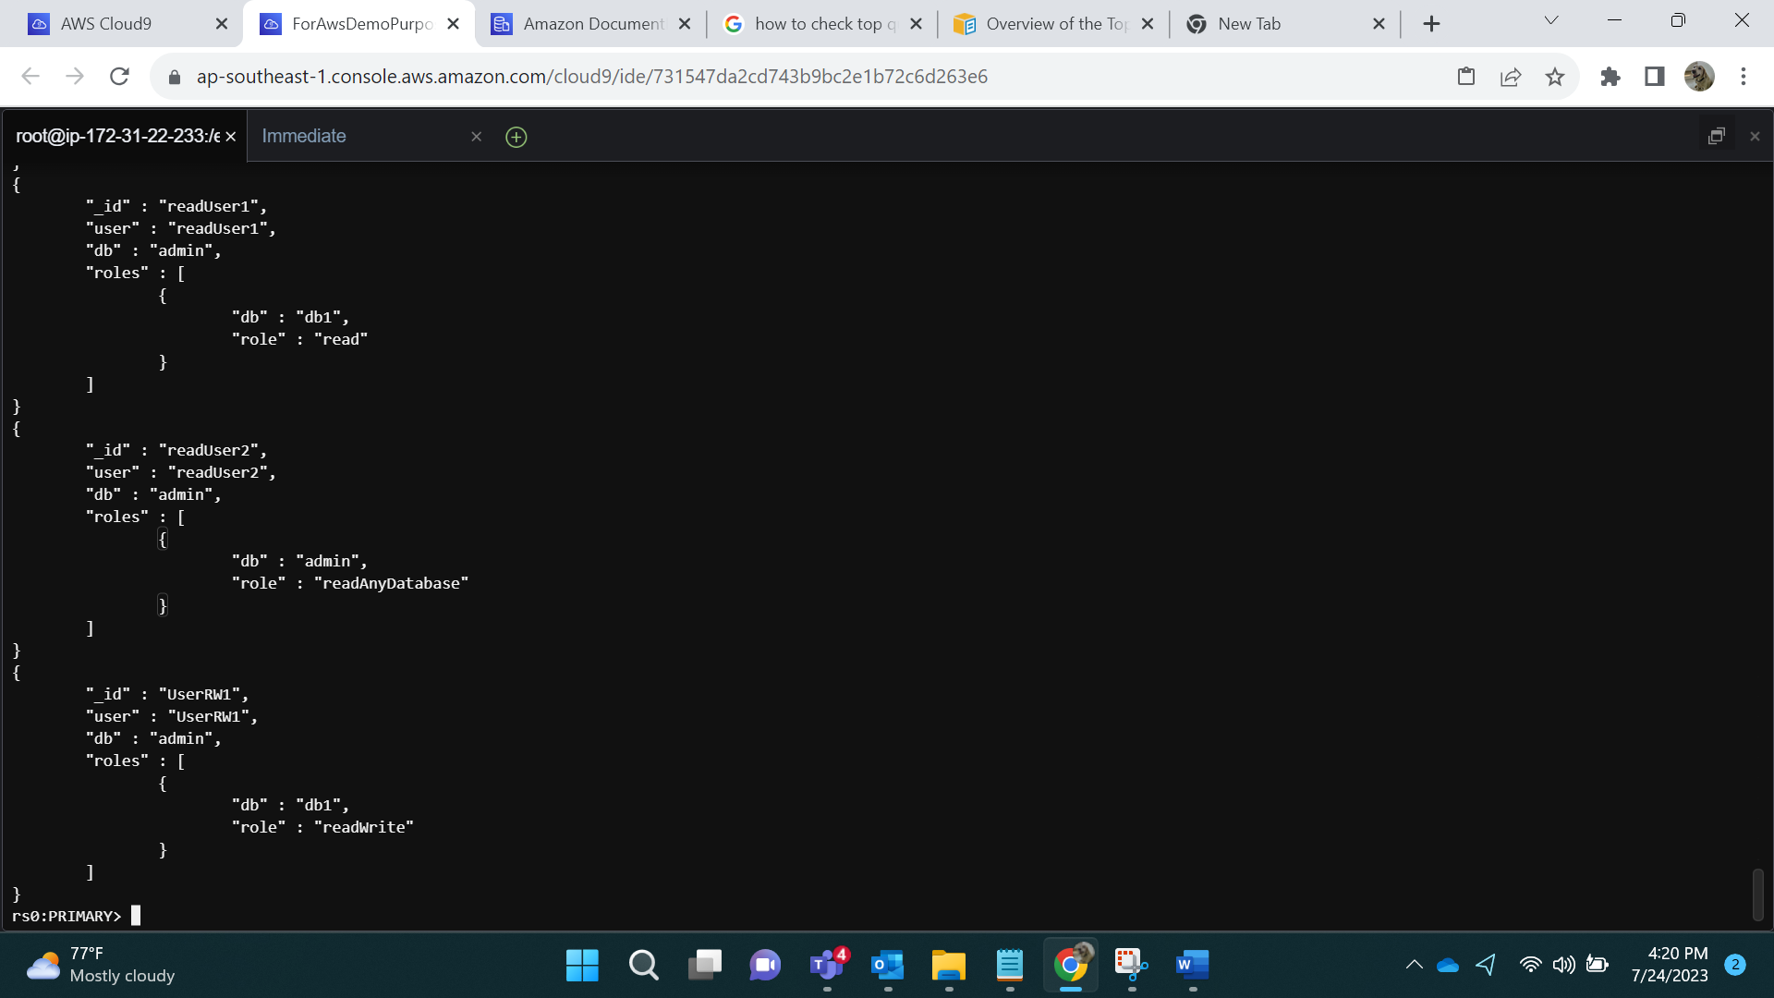

Logging in via UserRW1:

mongo --ssl --host forassin2first.cluster-cia4bvgv8e4r.ap-southeast-1.docdb.amazonaws.com:27017 --sslCAFile global-bundle.pem --username UserRW1 --password c@3

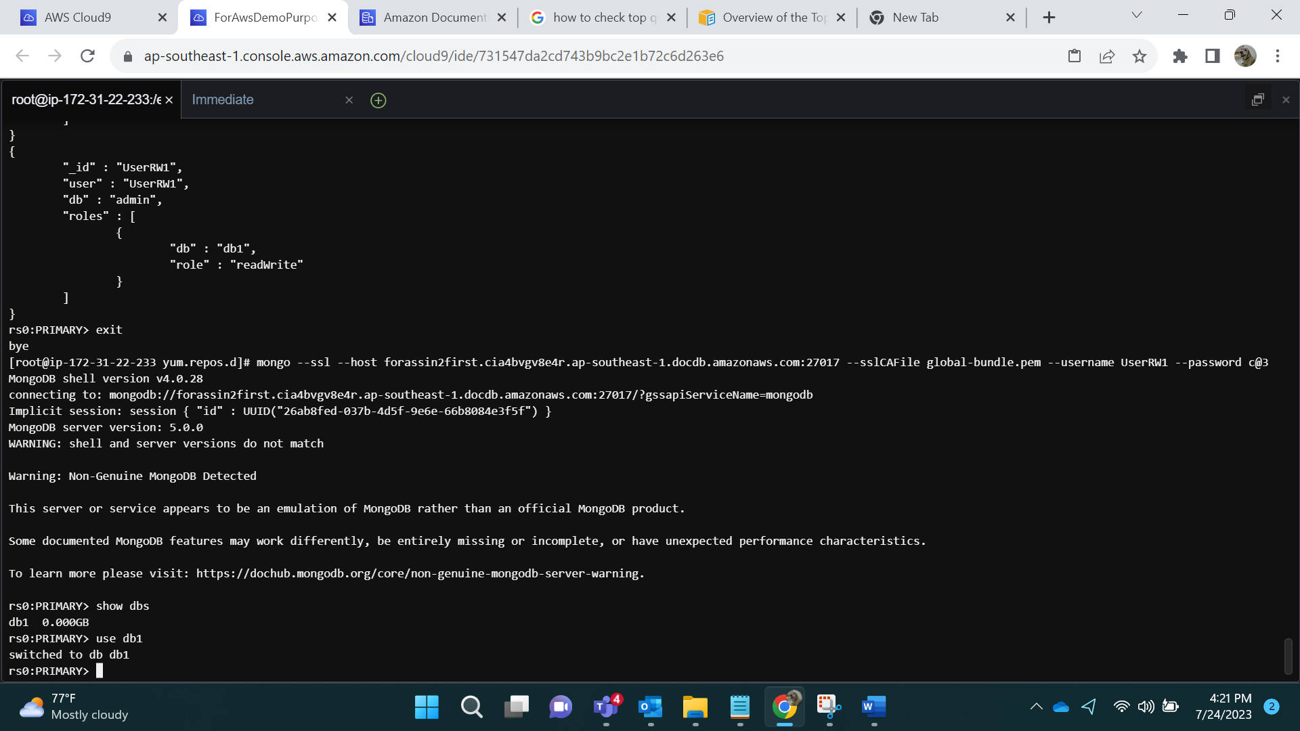

As we can observe, UserRW1 can only see db1.

Adding data into db1 via UserRW1.

db.table5.insertMany([

{ "_id" : 1, "name" : "Archis", "status": "active", "level": 6,"score":69},

{ "_id" : 2, "name" : "Devika", "status": "inactive", "level": 7,"score":70}

])

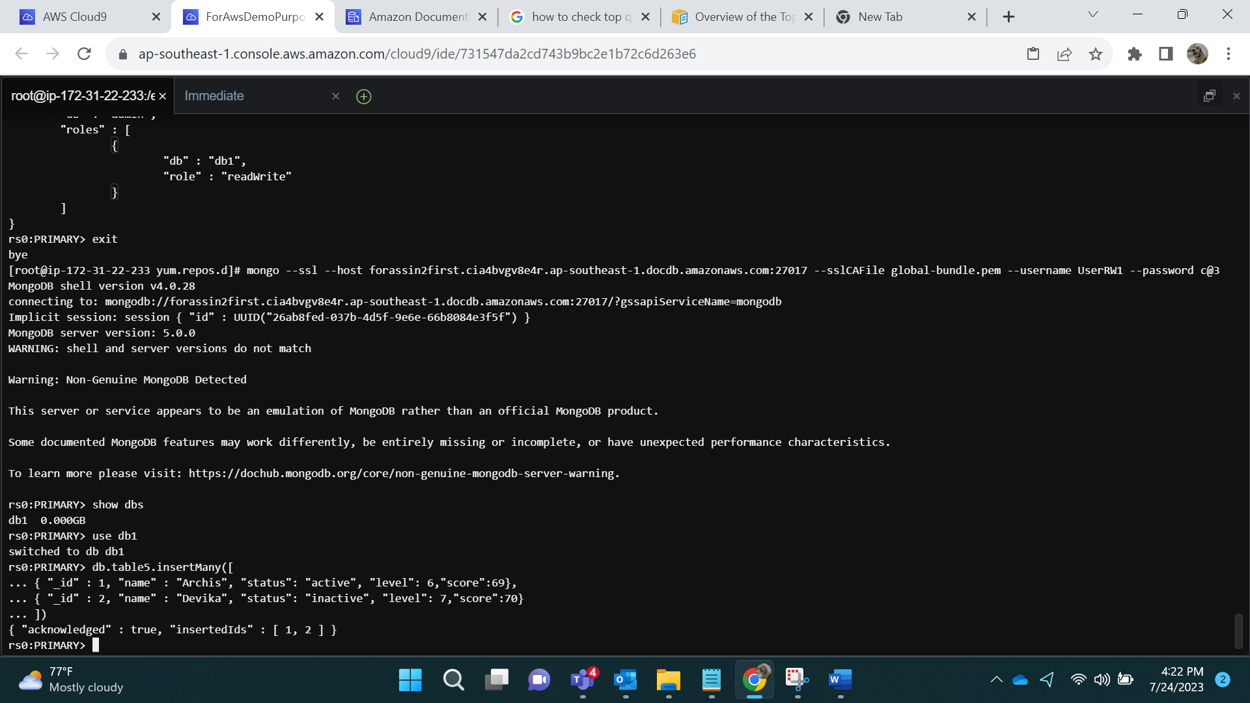

**- create a user with read and write access to all databases**

db.createUser({

user: "UserRW2",

pwd: "d@4",

roles: [ { role: "readWriteAnyDatabase", db: "admin" } ]

});

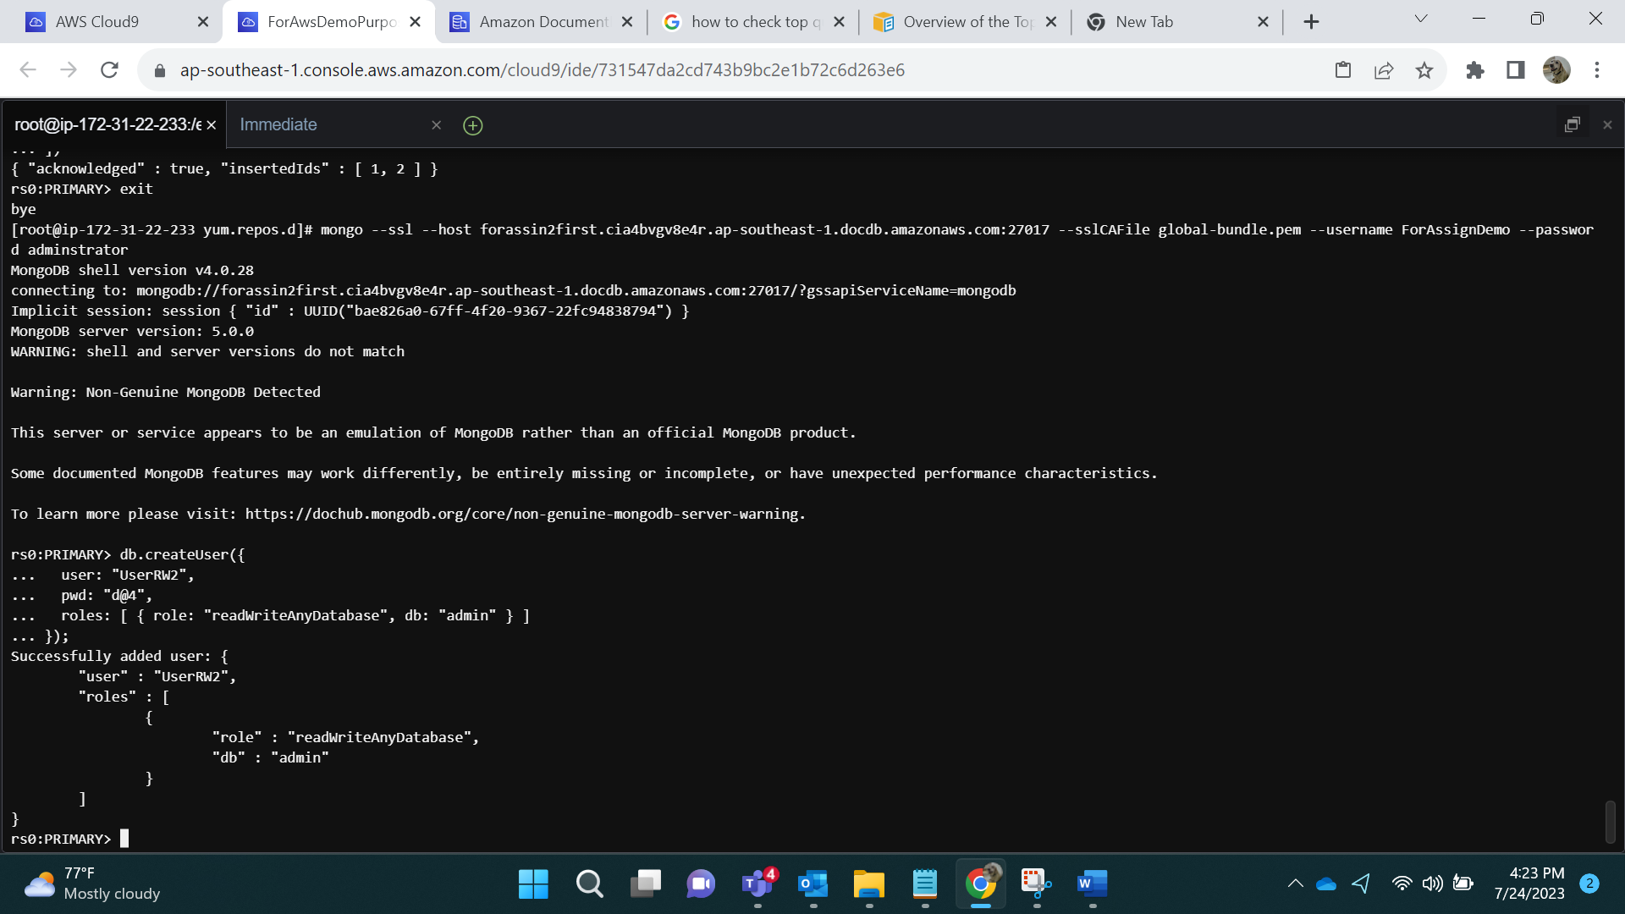

Show users:

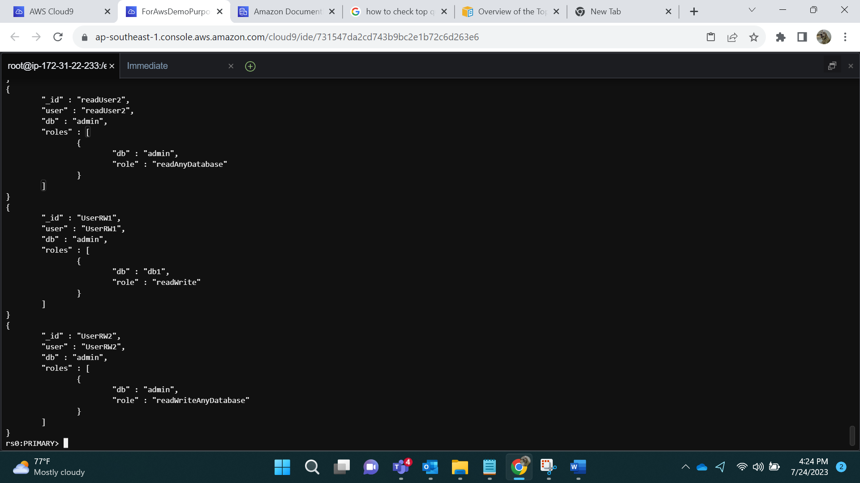

Logging in Via UserRW2:

mongo --ssl --host forassin2first.cluster-cia4bvgv8e4r.ap-southeast-1.docdb.amazonaws.com:27017 --sslCAFile global-bundle.pem --username UserRW2 --password d@4

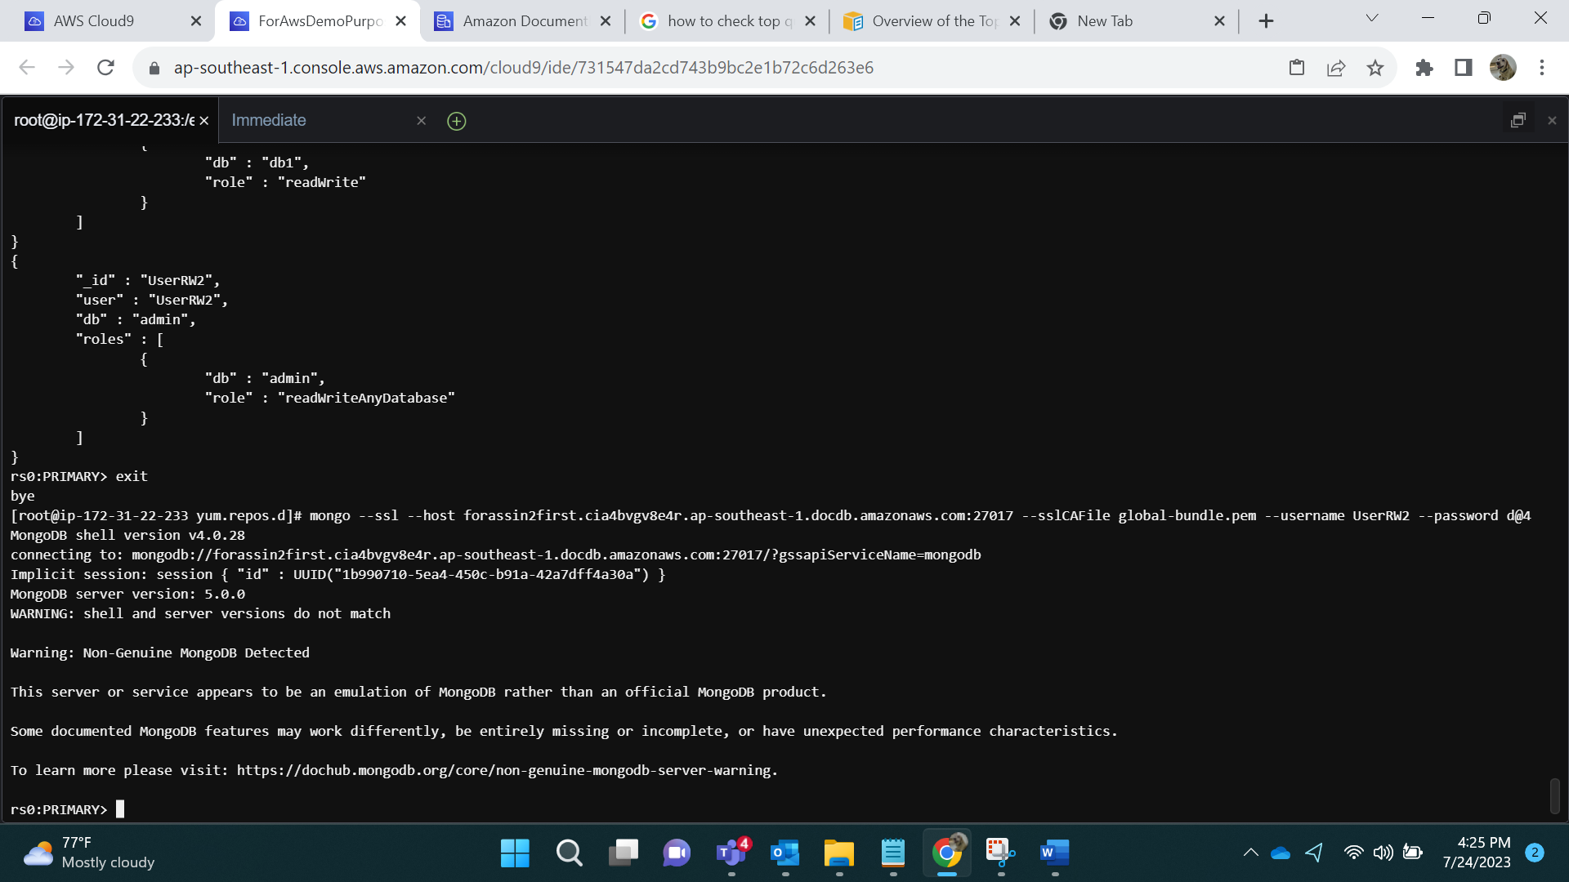

Showing databases and adding data to db1 and db2.

Use db1

db.table6.insertMany([

{ "_id" : 1, "name" : "Shikha", "status": "active", "level": 10,"score":55},

{ "_id" : 2, "name" : "Hemant", "status": "inactive", "level": 11,"score":66}

])

Use db2

db.table7.insertMany([

{ "_id" : 1, "name" : "AC", "status": "active", "level": 1,"score":99},

{ "_id" : 2, "name" : "Arpita", "status": "inactive", "level": 2,"score":66}

])

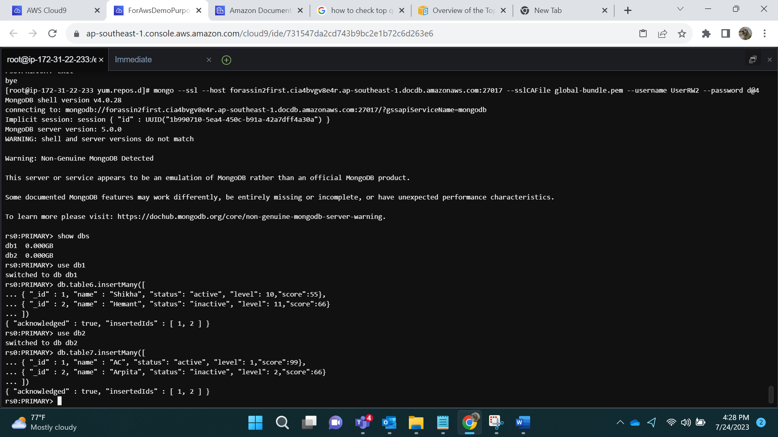

- **Grant read role to an existing user on a new database.**

For this we first need to create a user without any privileges.

db.createUser({user:"UserRW4", pwd: "e@5", roles:[]});

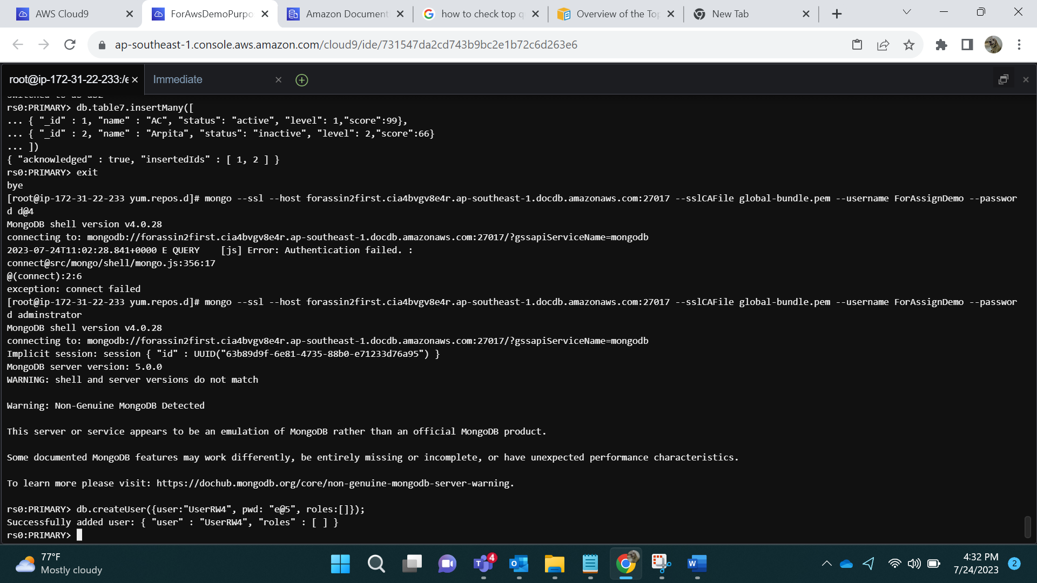

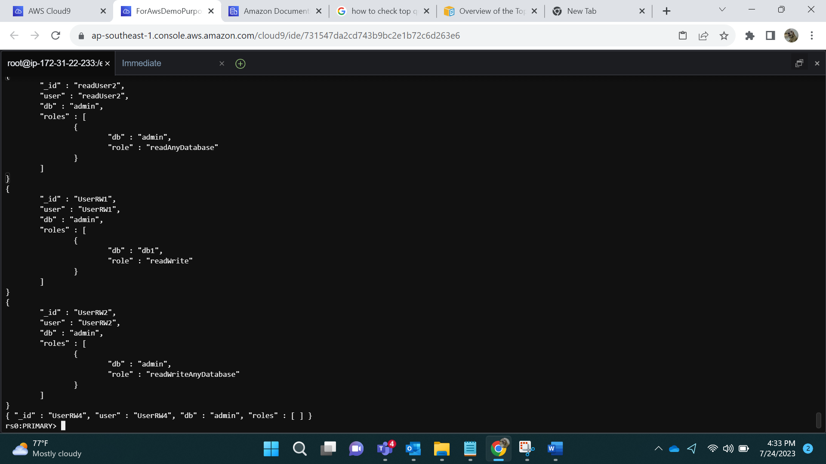

Logging in via UserRW4:

mongo --ssl --host forassin2first.cluster-cia4bvgv8e4r.ap-southeast-1.docdb.amazonaws.com:27017 --sslCAFile global-bundle.pem --username UserRW4 --password e@5

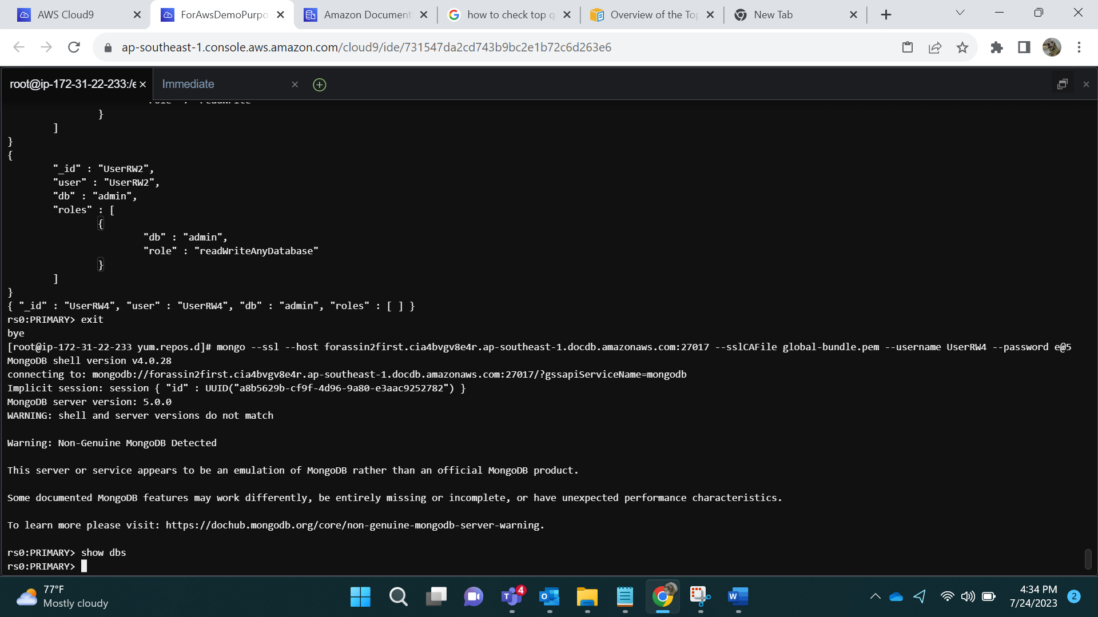

As we can see, user cannot see any databases.

Giving user read Roles via Admin login.

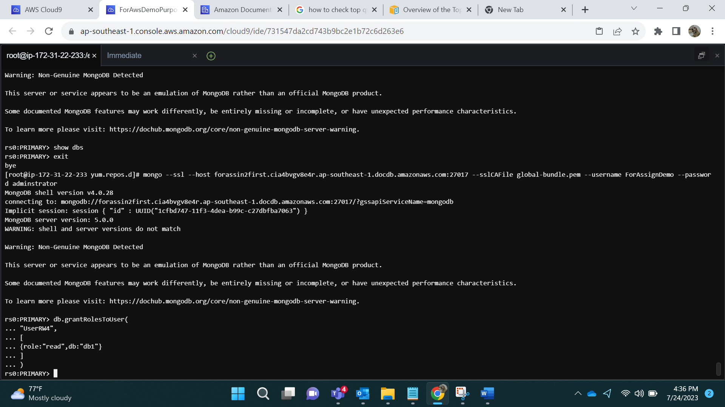

Logging in via RW4 and now user can see db1.

mongo --ssl --host forassin2first.cluster-cia4bvgv8e4r.ap-southeast-1.docdb.amazonaws.com:27017 --sslCAFile global-bundle.pem --username UserRW4 --password e@5

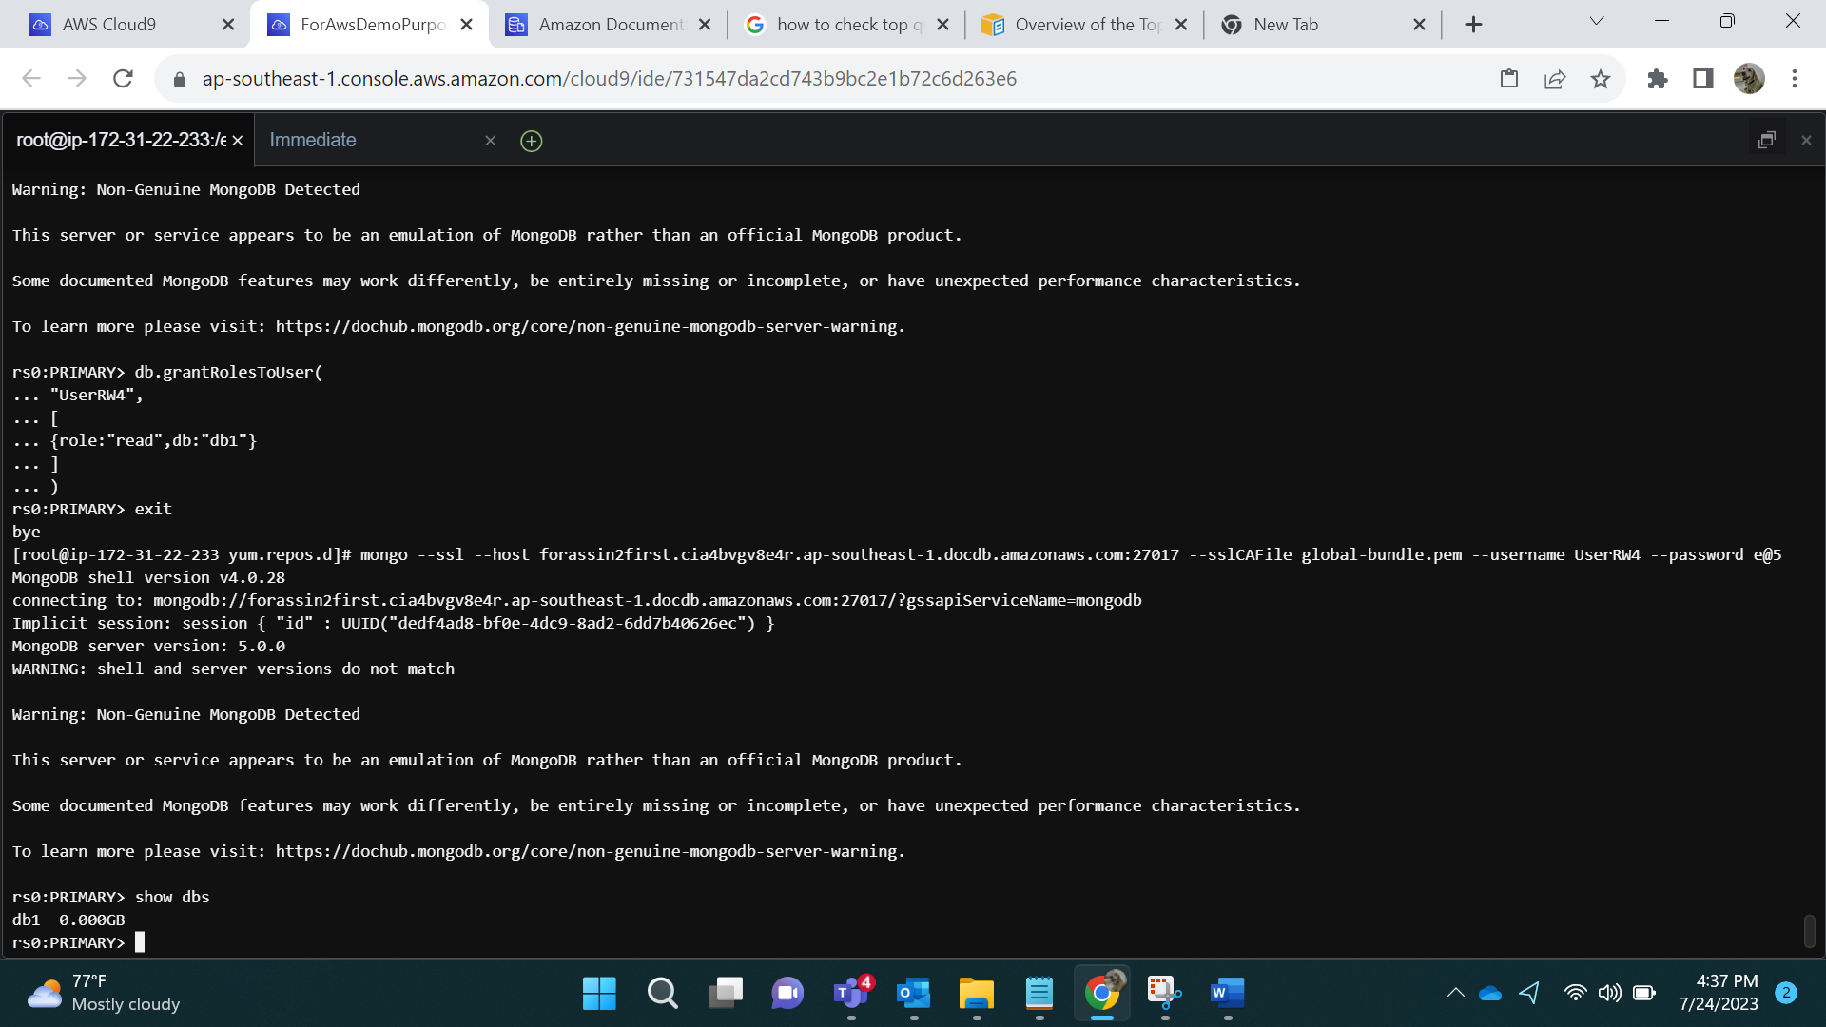

- **Revoke access to a database for a user.**

For that we first create a user and then revoke the access.

db.createUser({

user: "UserRW7",

pwd: "g@7",

roles: [ { role: "readWrite", db: "db1" } ]

});

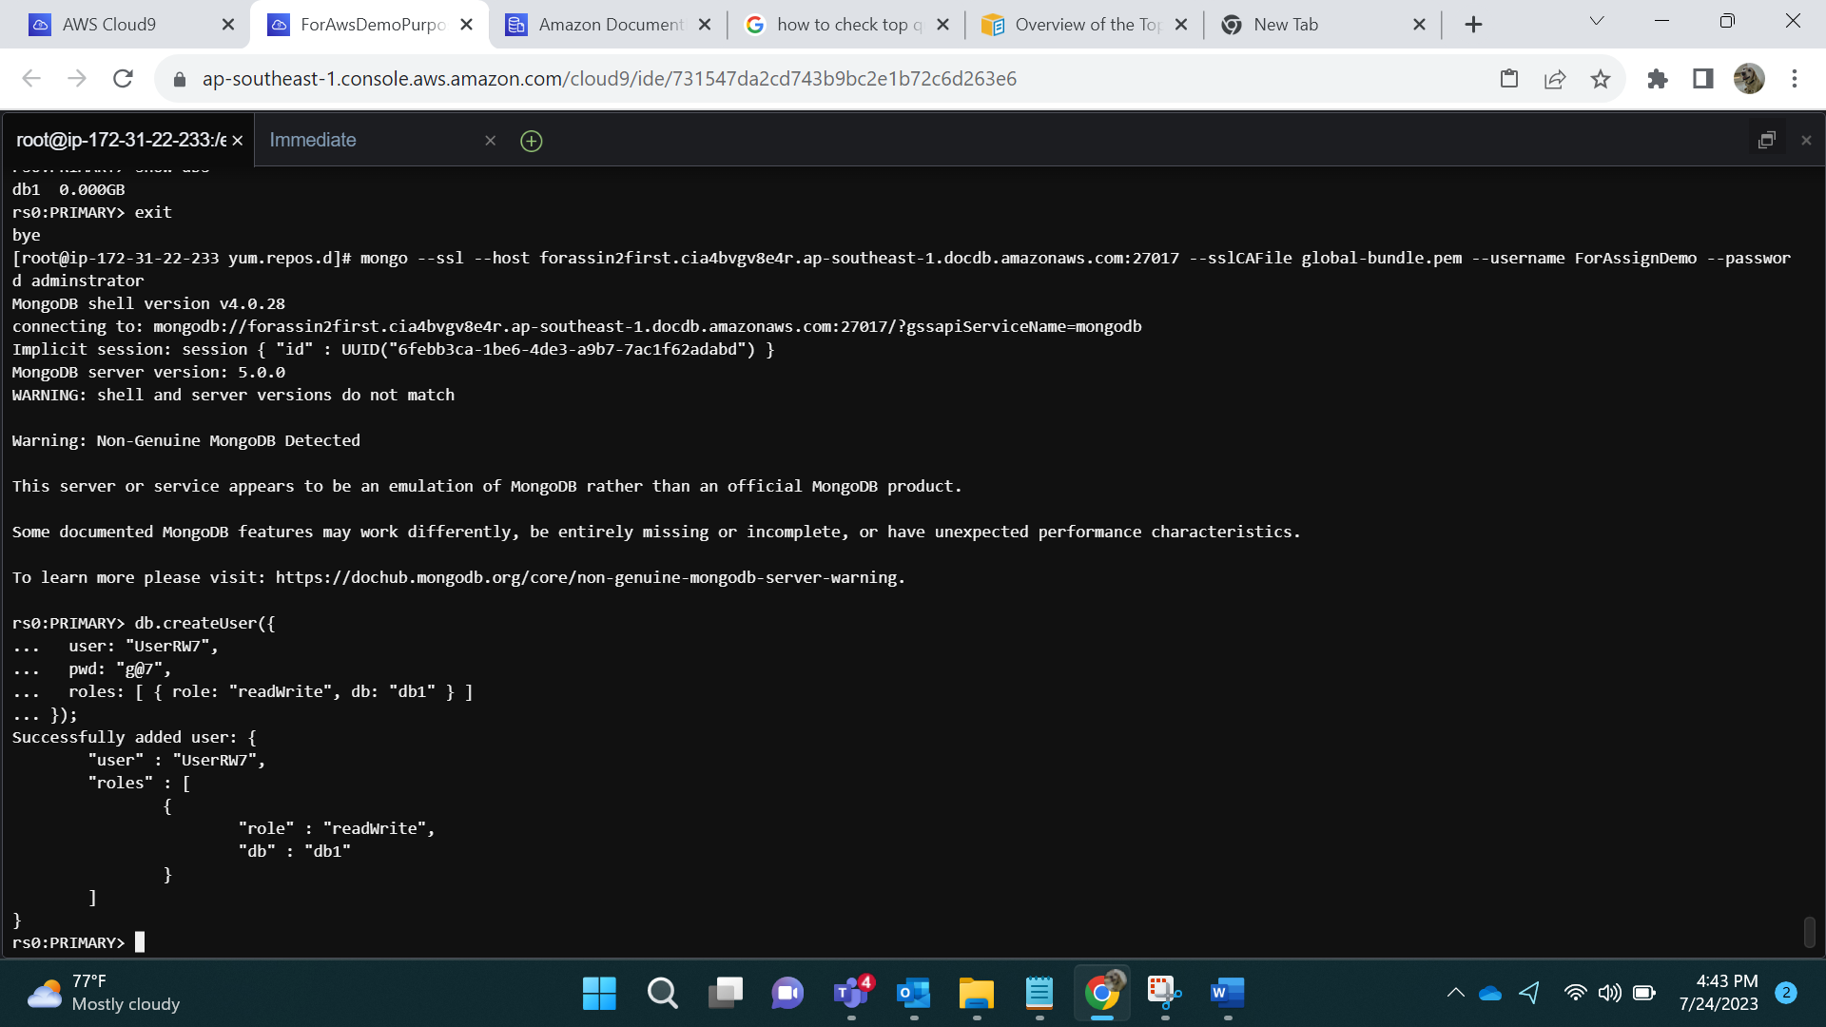

mongo --ssl --host forassin2first.cluster-cia4bvgv8e4r.ap-southeast-1.docdb.amazonaws.com:27017 --sslCAFile global-bundle.pem --username UserRW7 –password g@7

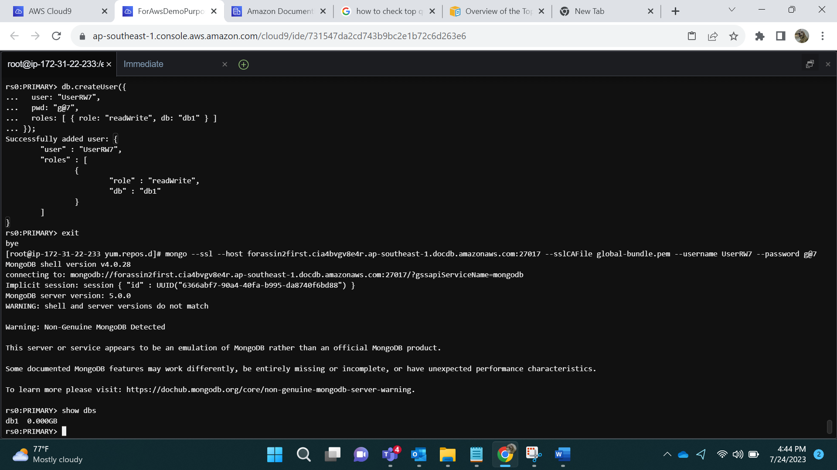

Revoking Roles from UserRW7 via Admin:

db.revokeRolesFromUser("UserRW7", [{role:"readWrite",db:"db1"}])

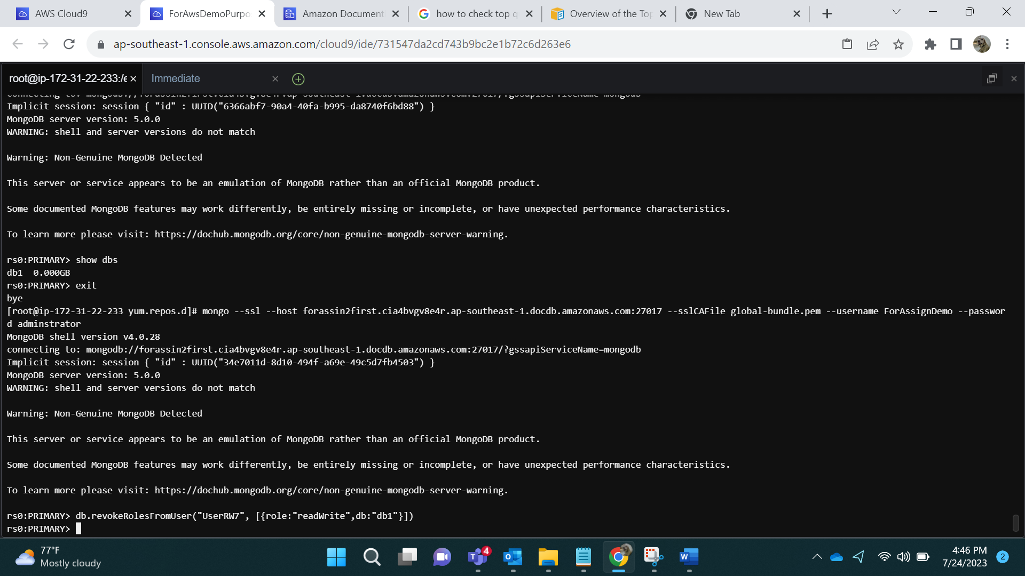

mongo --ssl --host forassin2first.cluster-cia4bvgv8e4r.ap-southeast-1.docdb.amazonaws.com:27017 --sslCAFile global-bundle.pem --username UserRW7 --password g@7

After revoking access

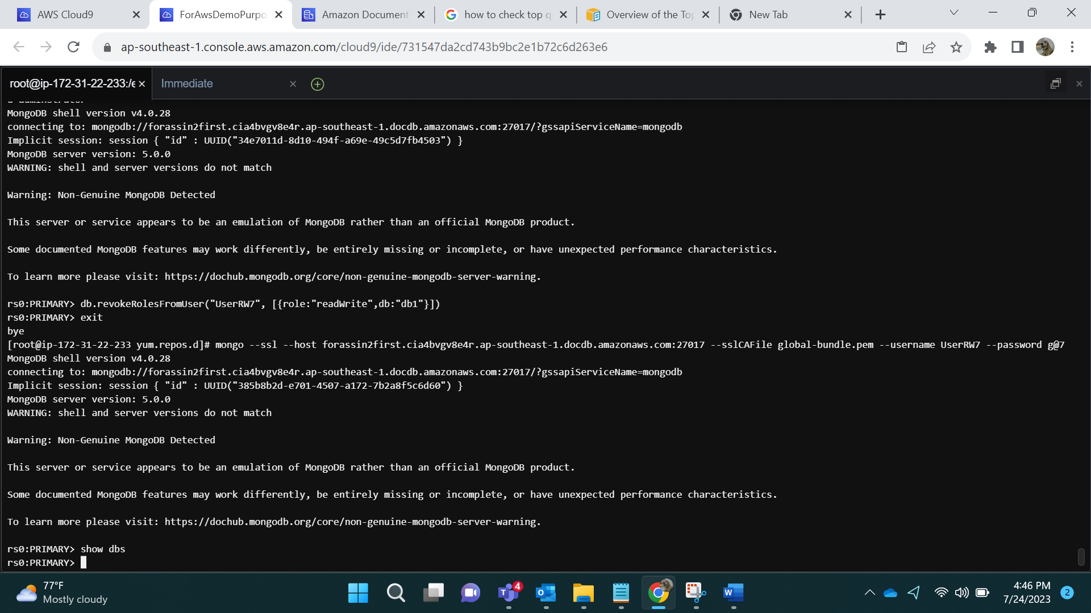

**- Update a user's role.**

db.createUser({user:"UserRW8",pwd:"h@8",roles:[{role: "readAnyDatabase",db:"admin"}]})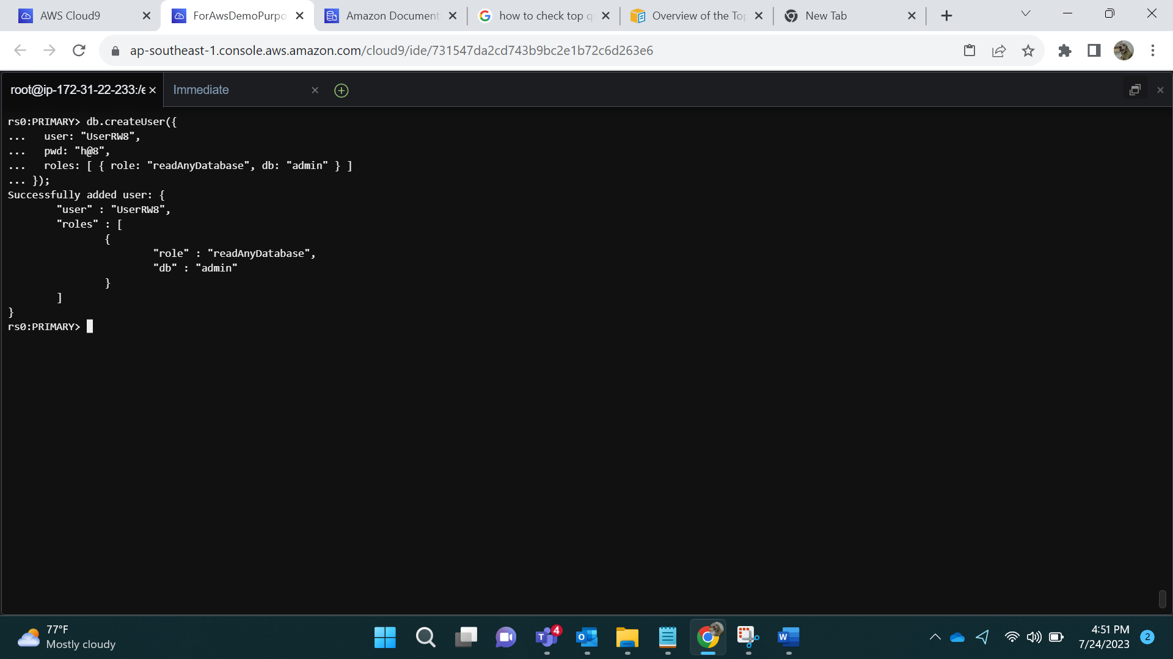

Logging in via UserRW8:

mongo --ssl --host forassin2first.cluster-cia4bvgv8e4r.ap-southeast-1.docdb.amazonaws.com:27017 --sslCAFile global-bundle.pem --username UserRW8 --password h@8

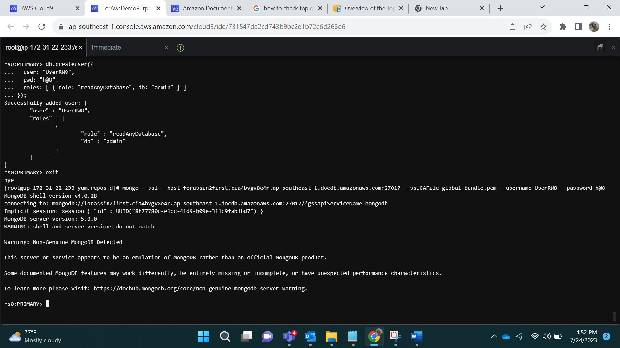

Adding Data will give error as follows:

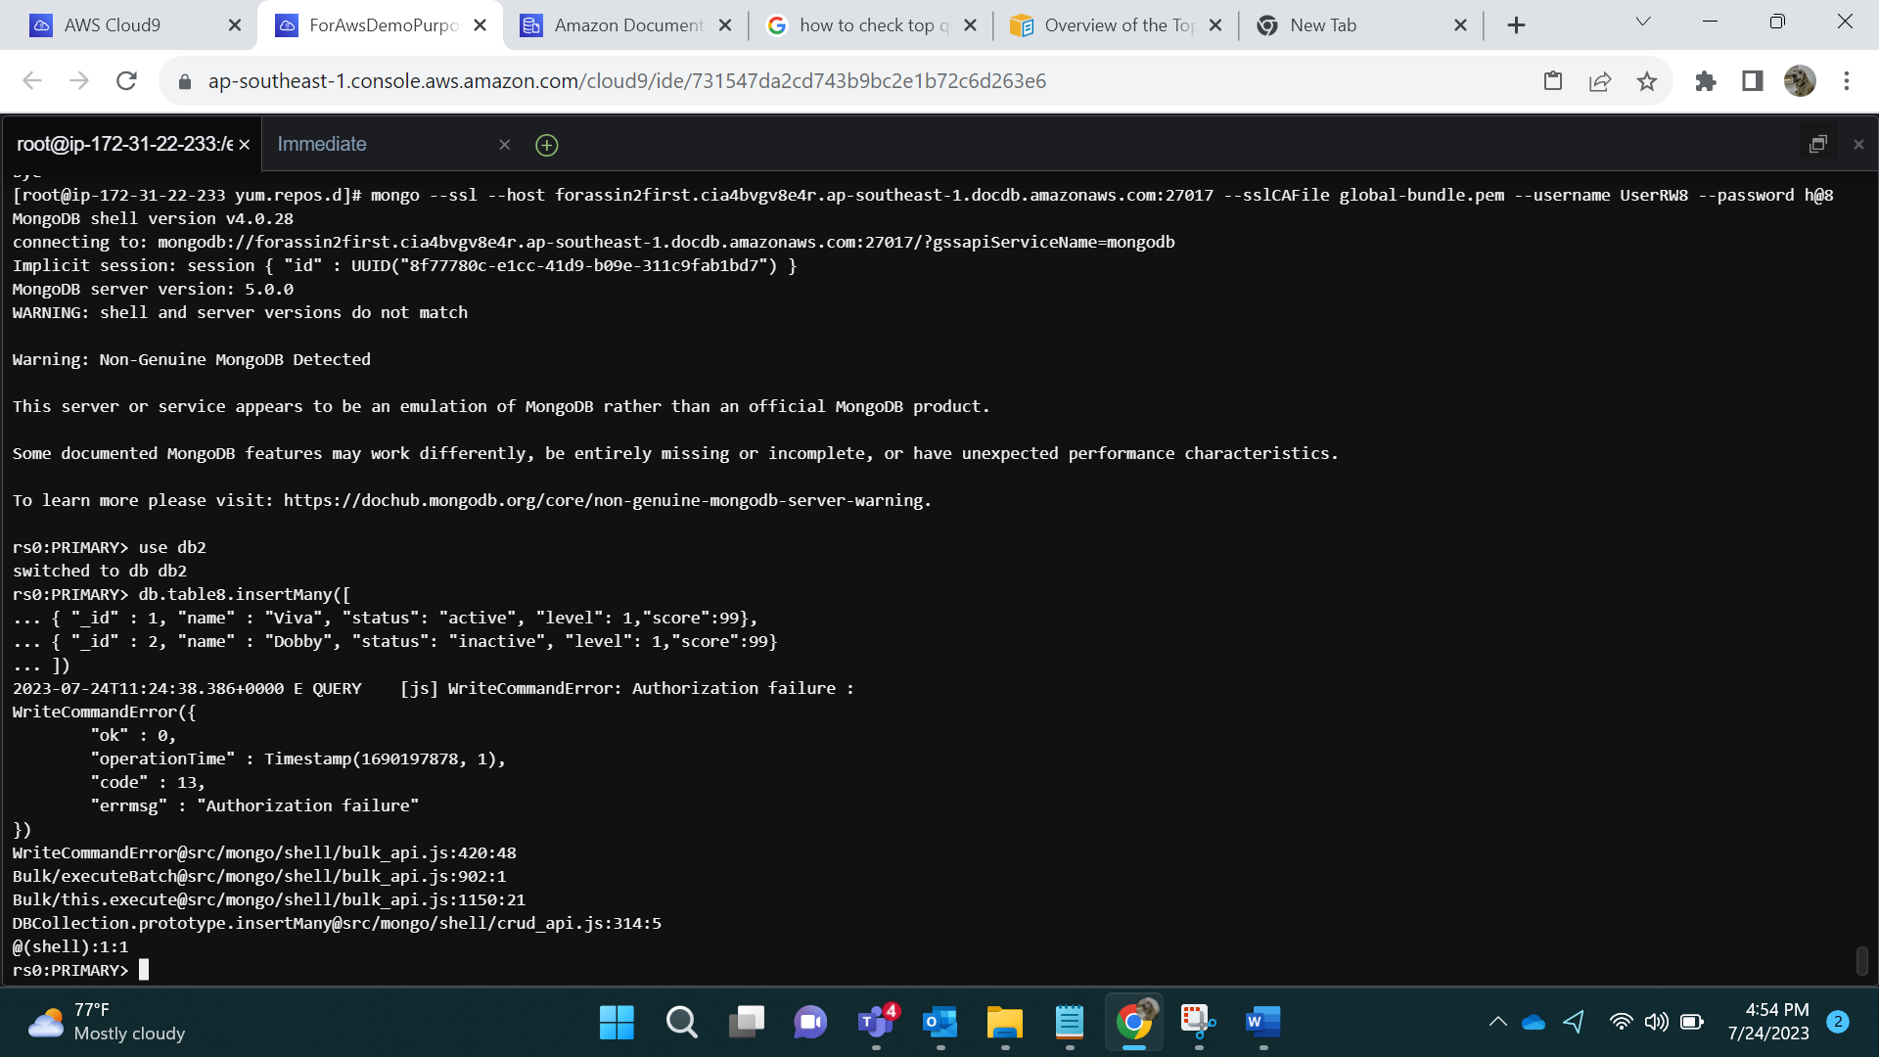

Updating rules Via Admin.

db.updateUser({user:"UserRW8", roles:[{role: "readWriteAnyDatabase",db:"admin"}]})

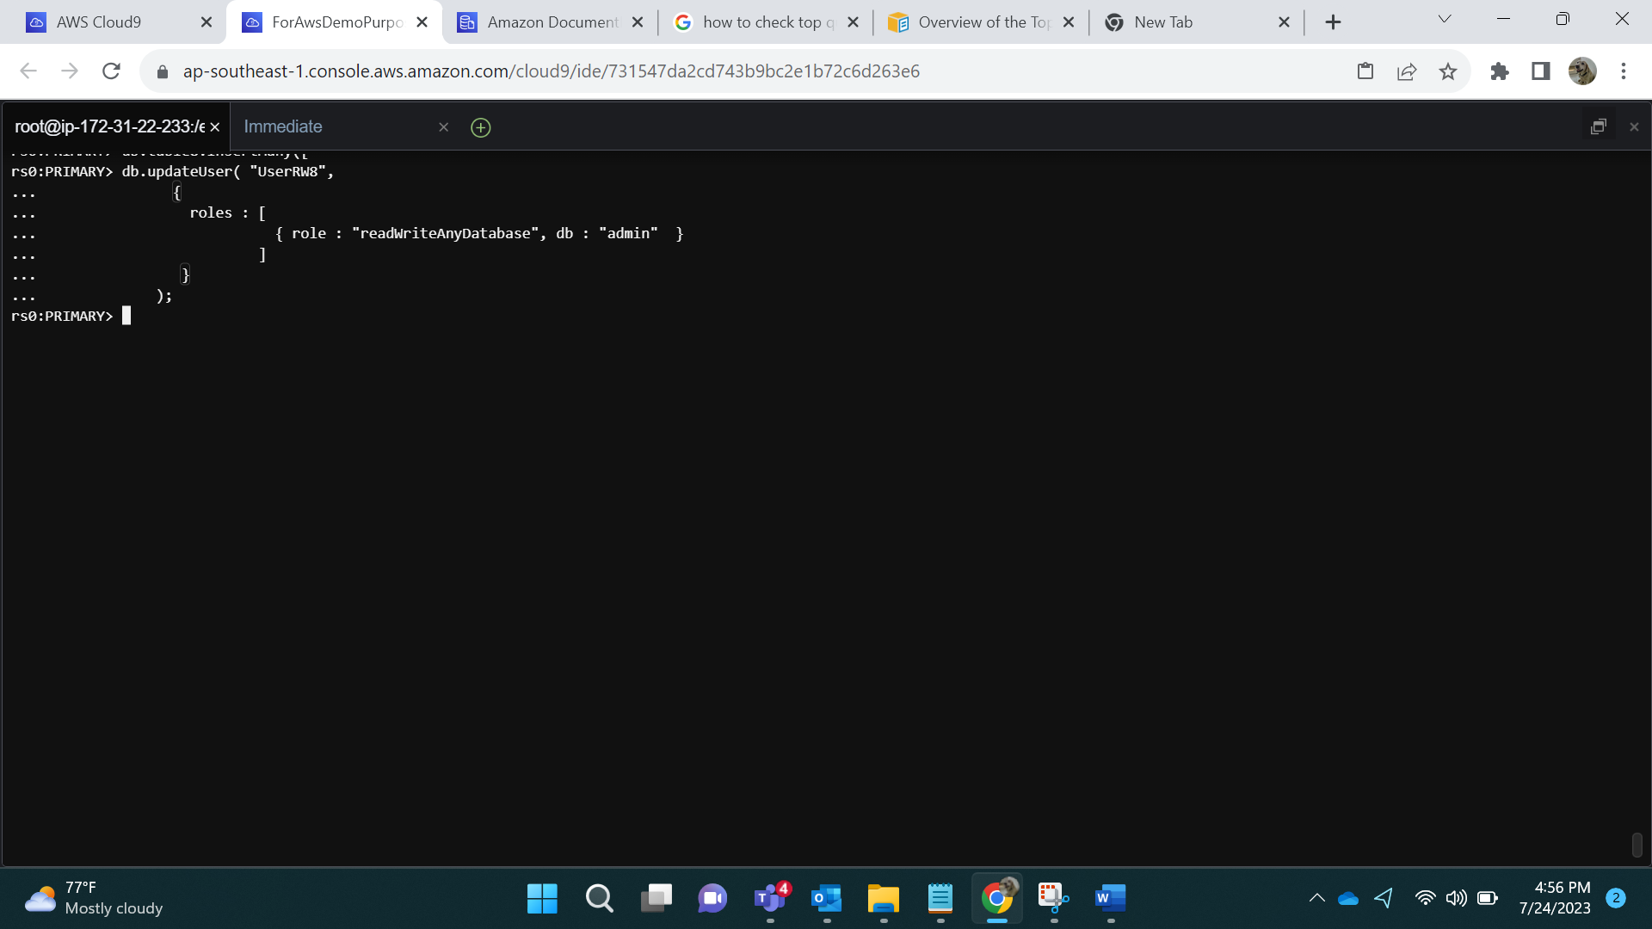

Result by show users:

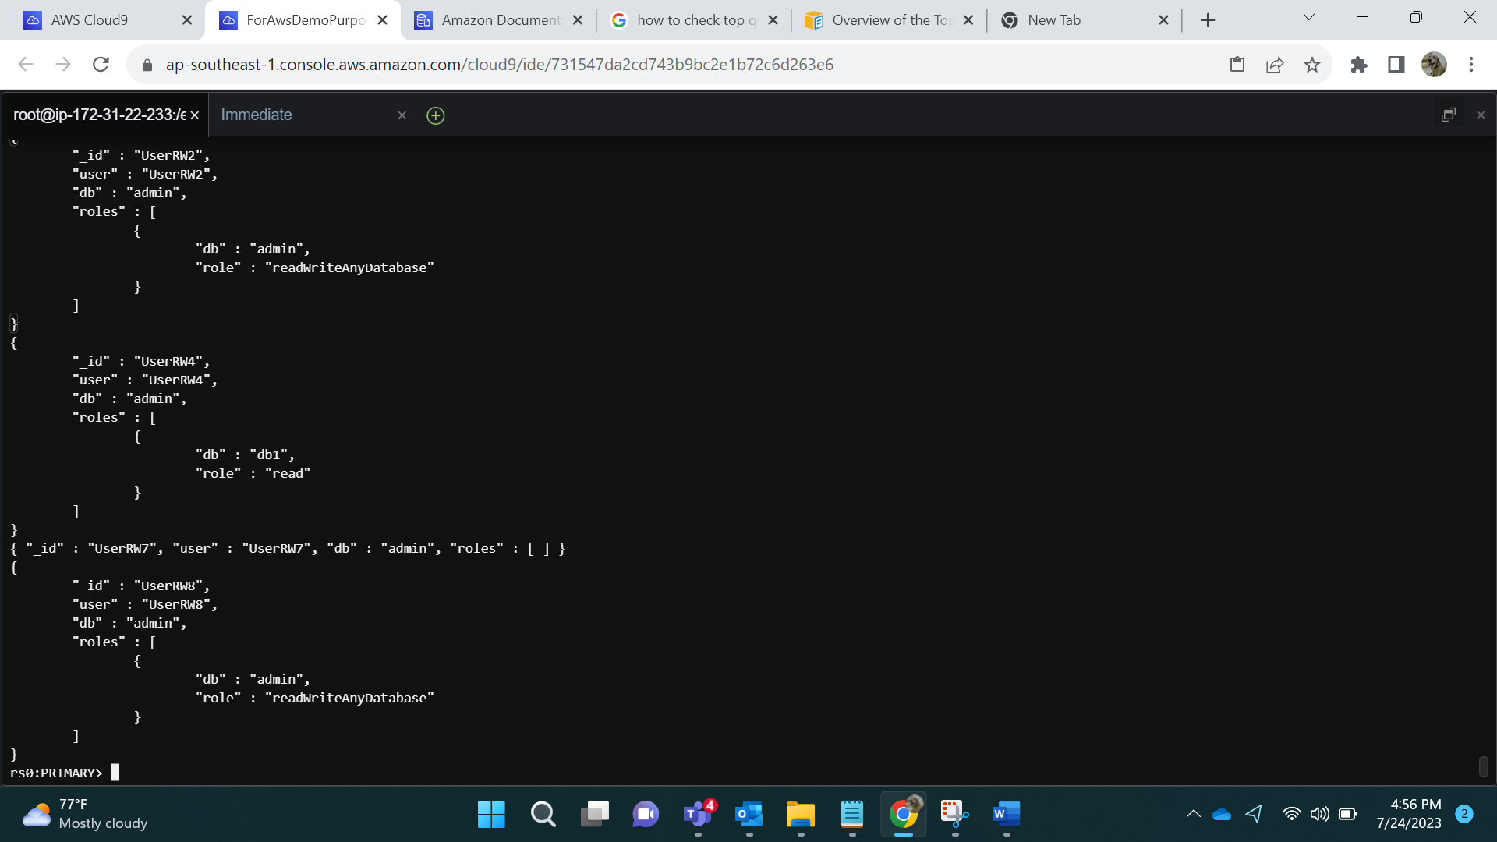

Logging in via UserRW8:

mongo --ssl --host forassin2first.cluster-cia4bvgv8e4r.ap-southeast-1.docdb.amazonaws.com:27017 --sslCAFile global-bundle.pem --username UserRW8 --password h@8

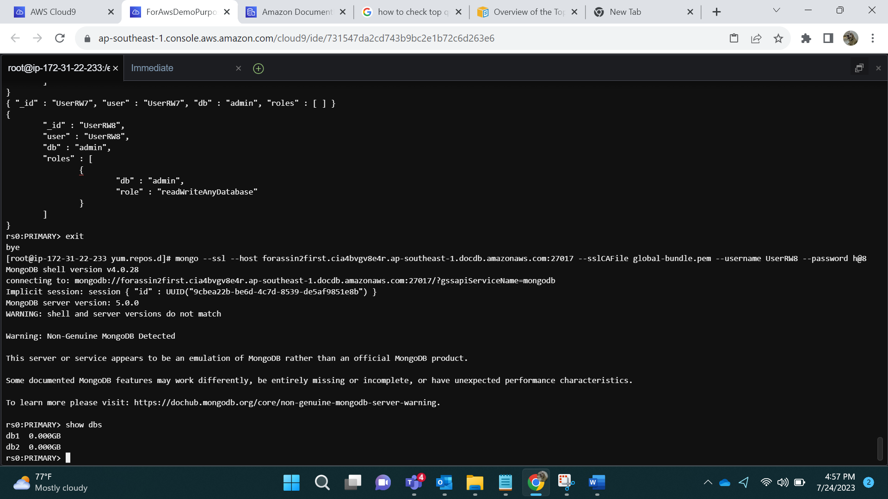

Adding Data:

db.table8.insertMany([

{ "_id" : 1, "name" : "Viva", "status": "active", "level": 1,"score":99},

{ "_id" : 2, "name" : "Dobby", "status": "inactive", "level": 1,"score":99}

])

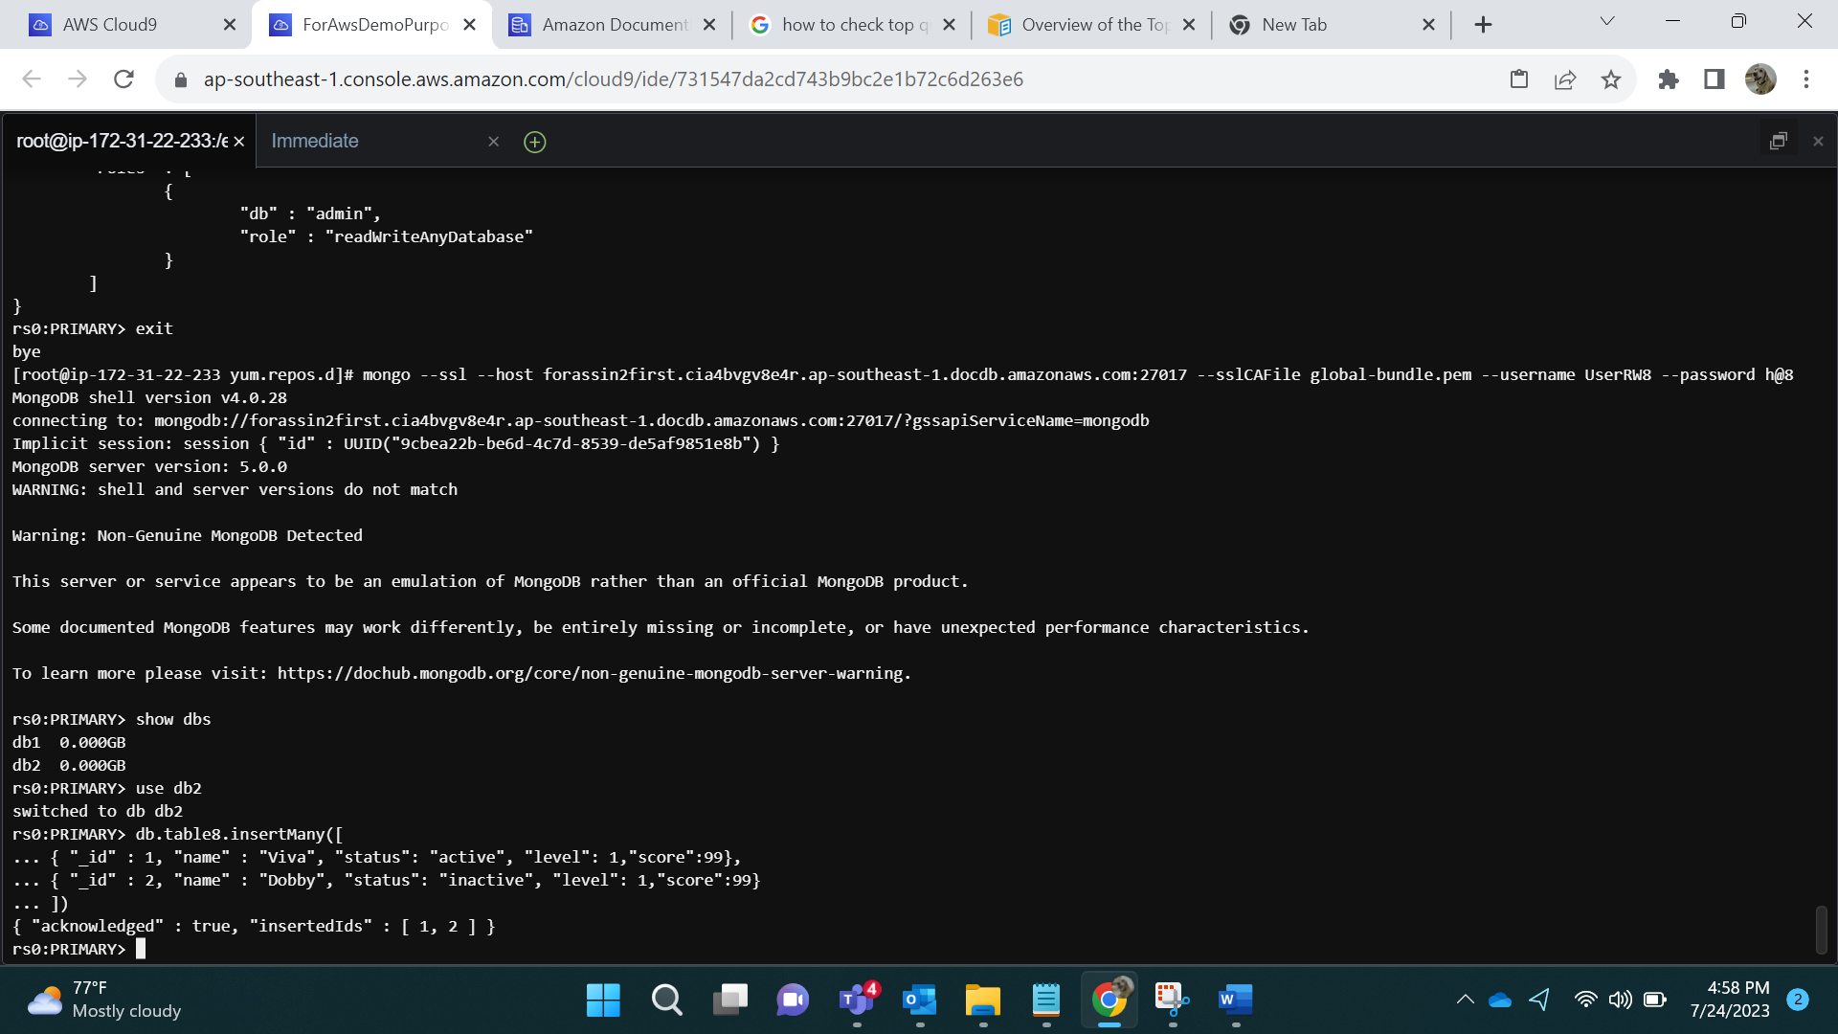

User can add data in db2

**- User define Roles :**

- Create a role with read and write access to a specific collection

db.createRole(

{

role: "forUserRW9",

privileges:[{resource:{db:"db1",collection:"table6"},actions:["find"]}],

roles:[{role: "readWrite",db:"admin"}]

})

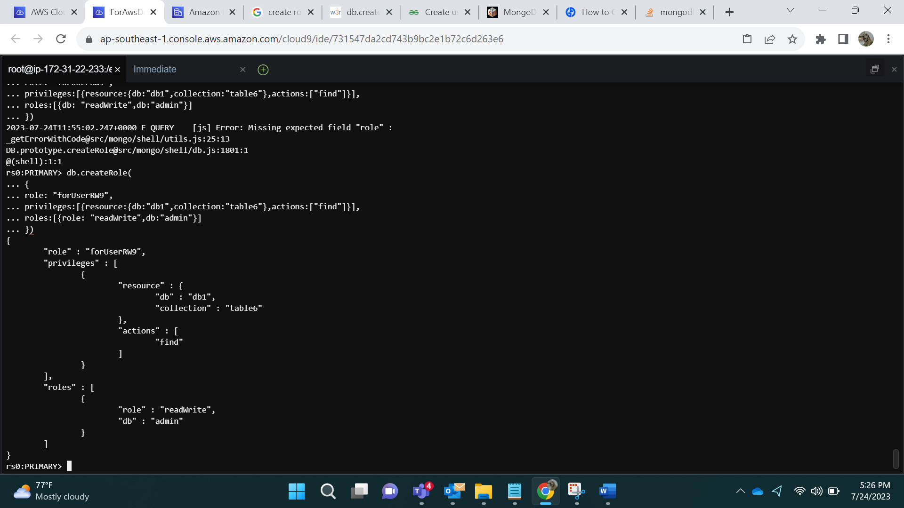

Show roles:

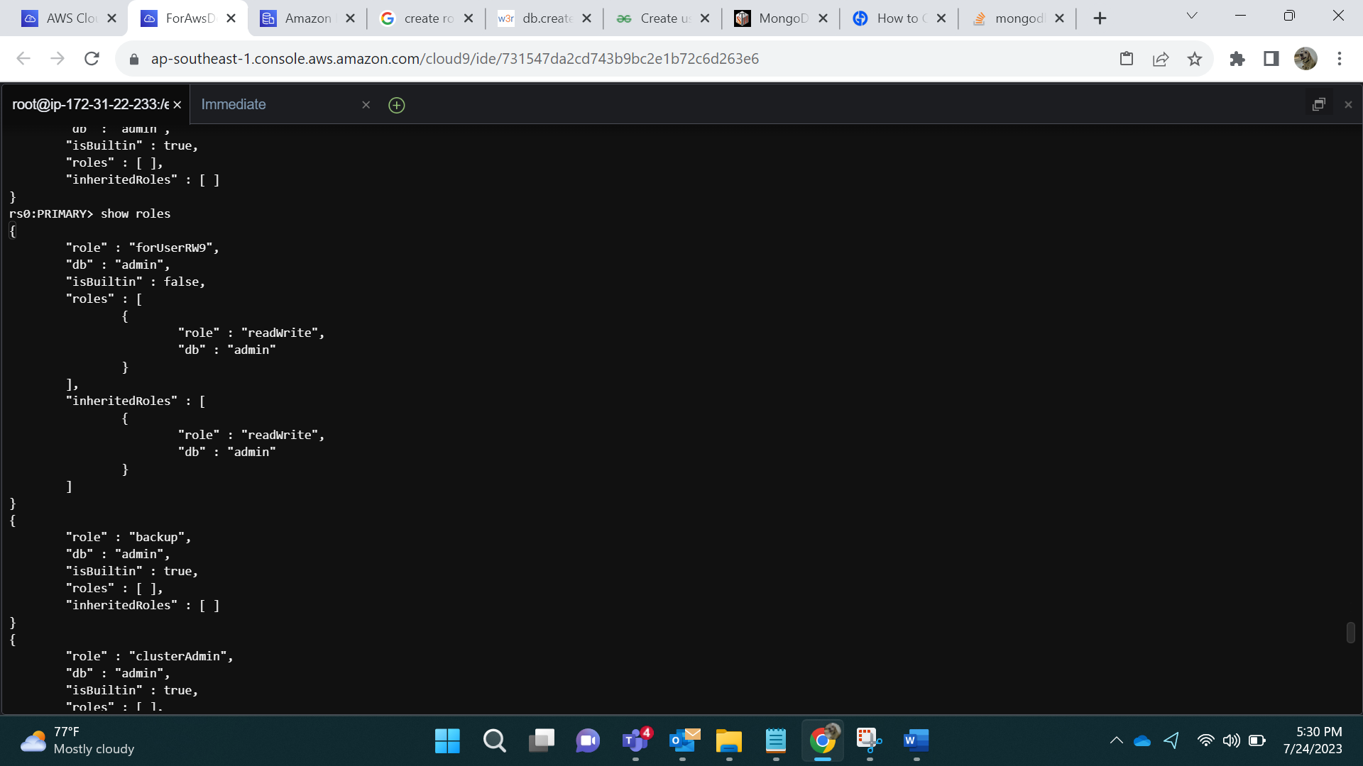

Assigning this role to User:

db.createUser({user:"UserRW9",pwd:"j@10",roles:["forUserRW9"]})

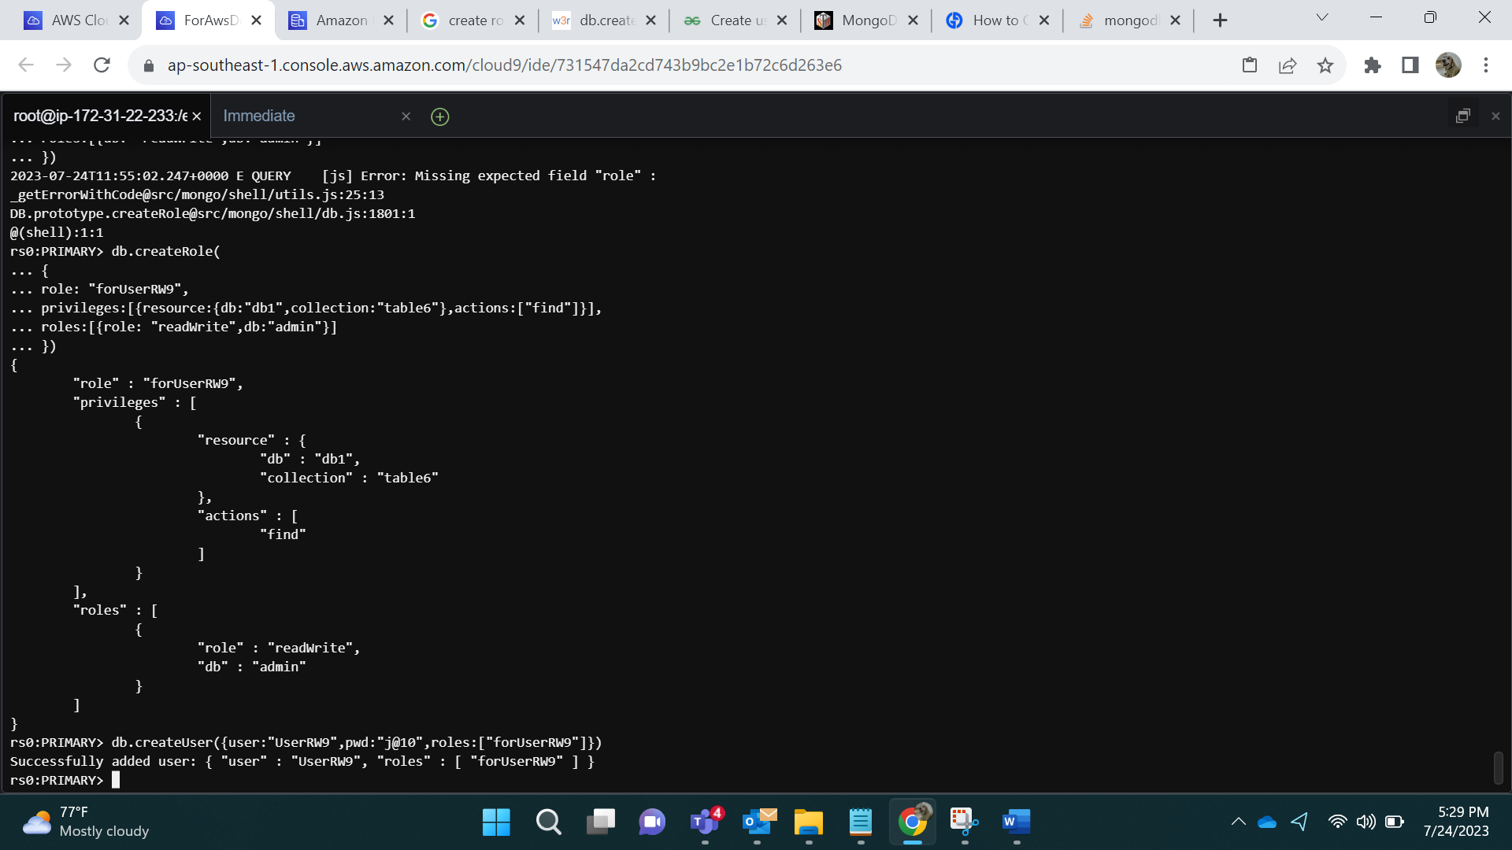

After logging in by User:

mongo --ssl --host forassin2first.cluster-cia4bvgv8e4r.ap-southeast-1.docdb.amazonaws.com:27017 --sslCAFile global-bundle.pem --username UserRW9 --password j@10

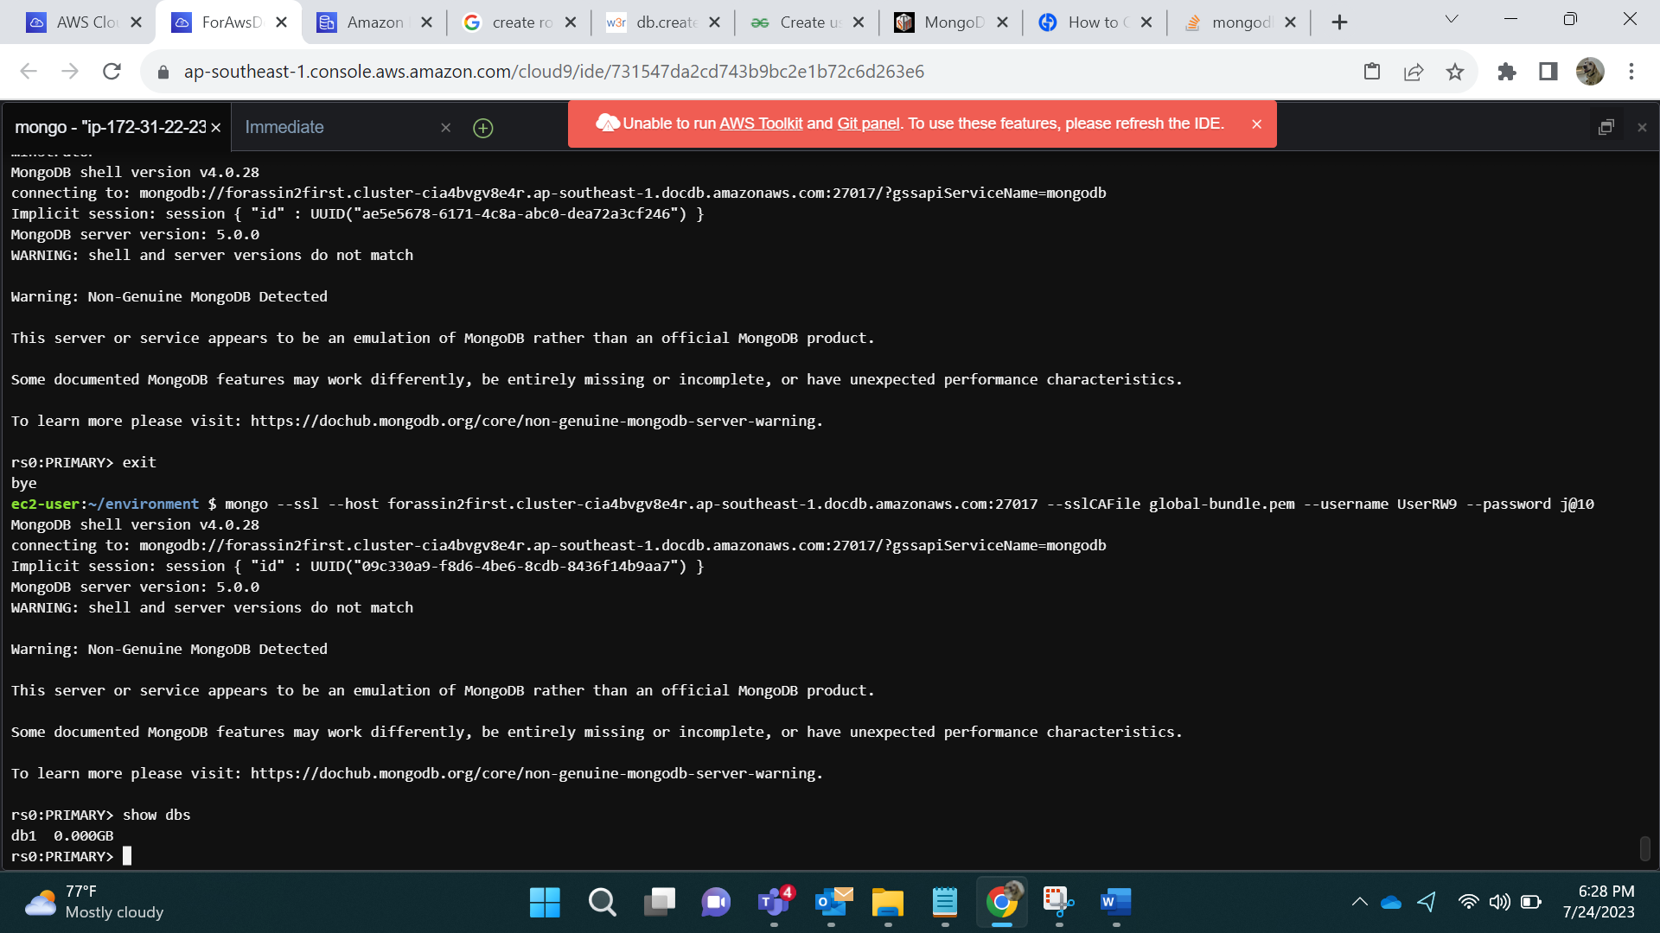

- **Create a user and assign a user defined role**

db.createRole(

{

role: "forUserRW10",

privileges:[{resource:{db:"",collection:""},actions:["find"]}],

roles:[{role: "read",db:"admin"}]

})

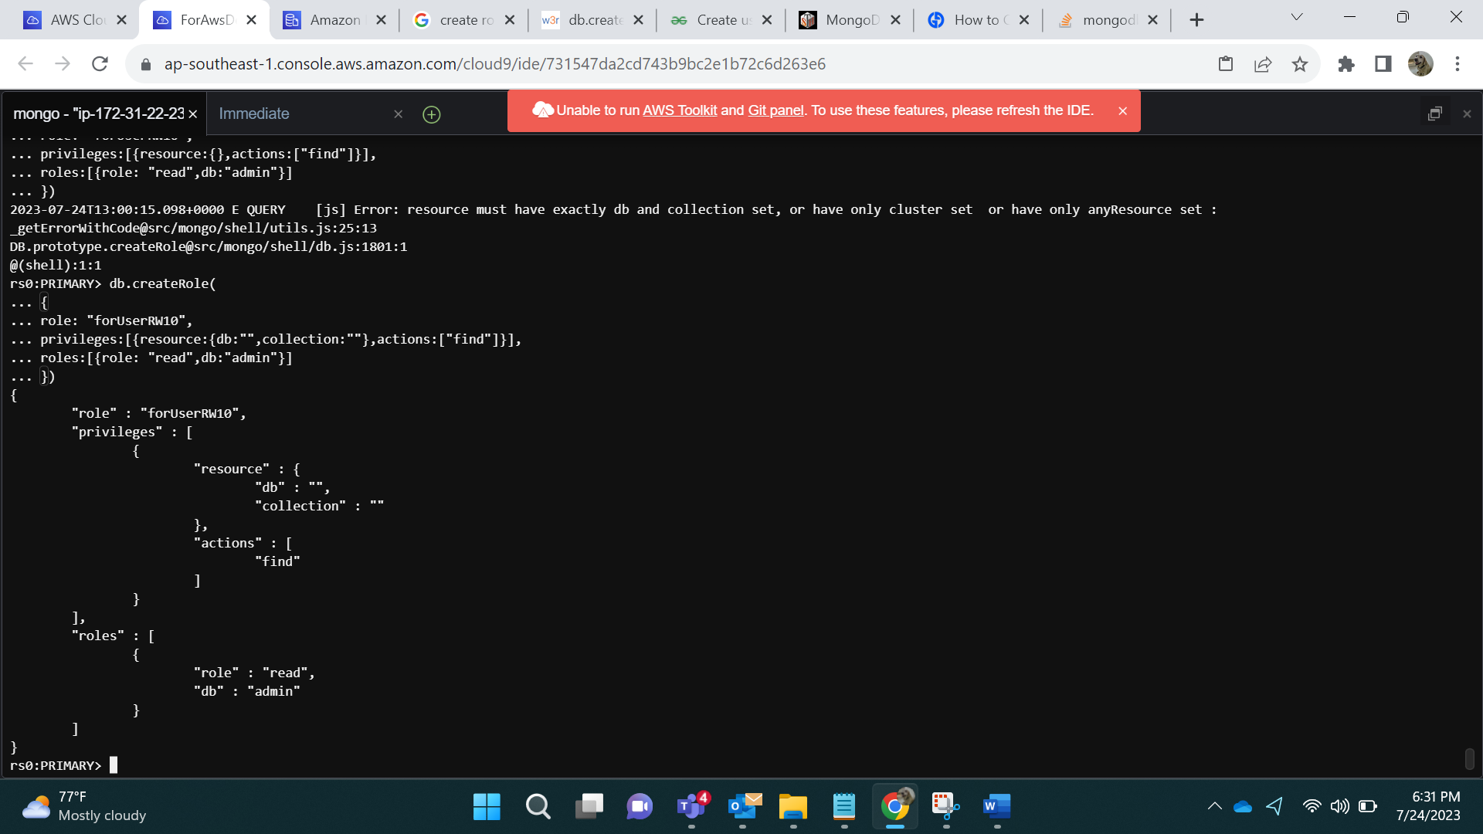

Assigning Roles to Users:

db.createUser({user:"UserRW10",pwd:"k@11",roles:["forUserRW10"]})

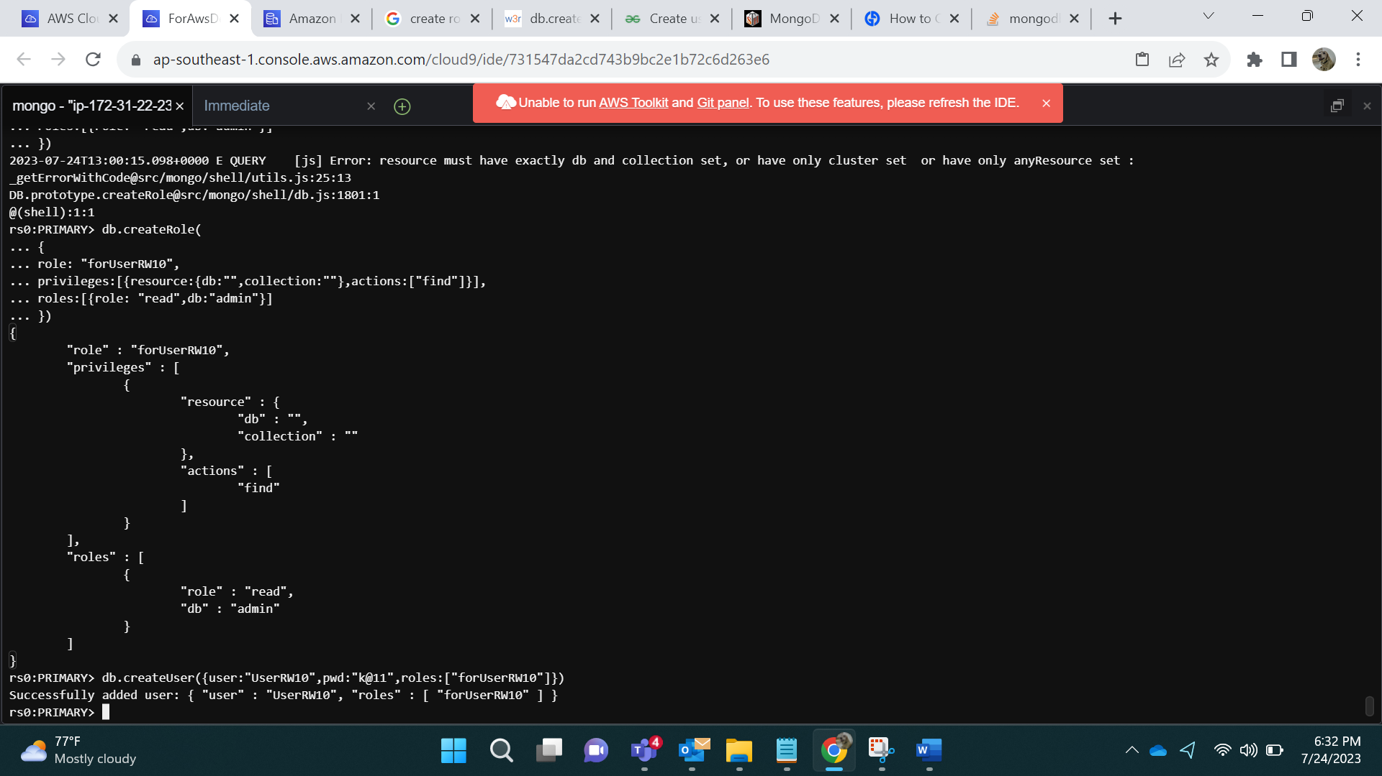

Show Roles:

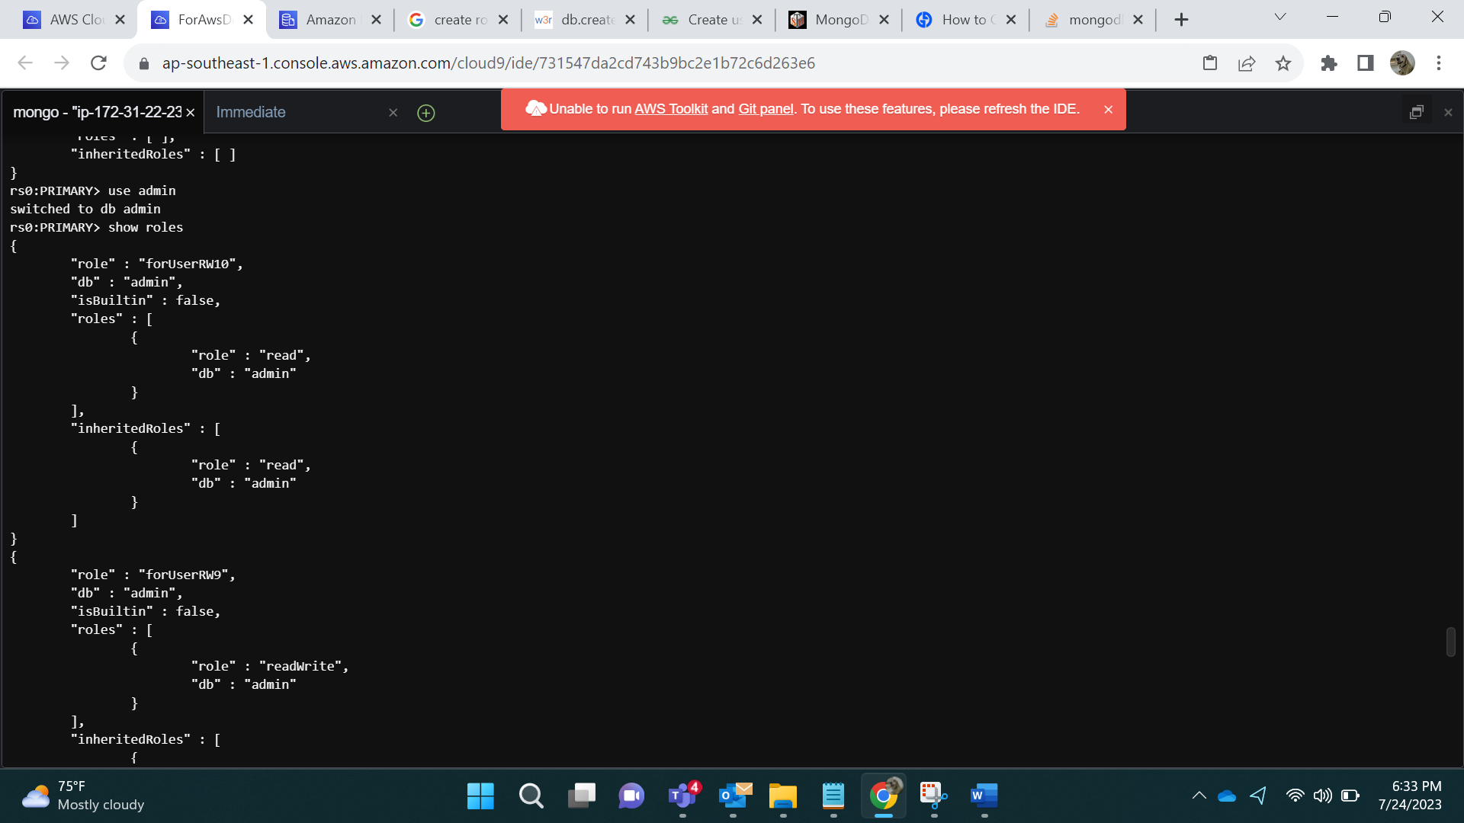

Show users:

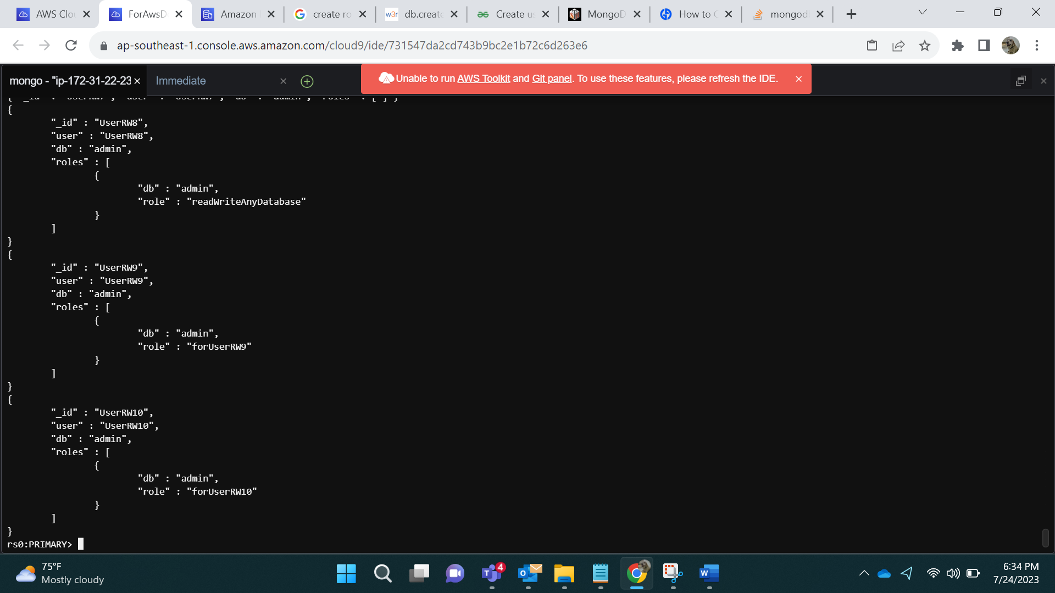

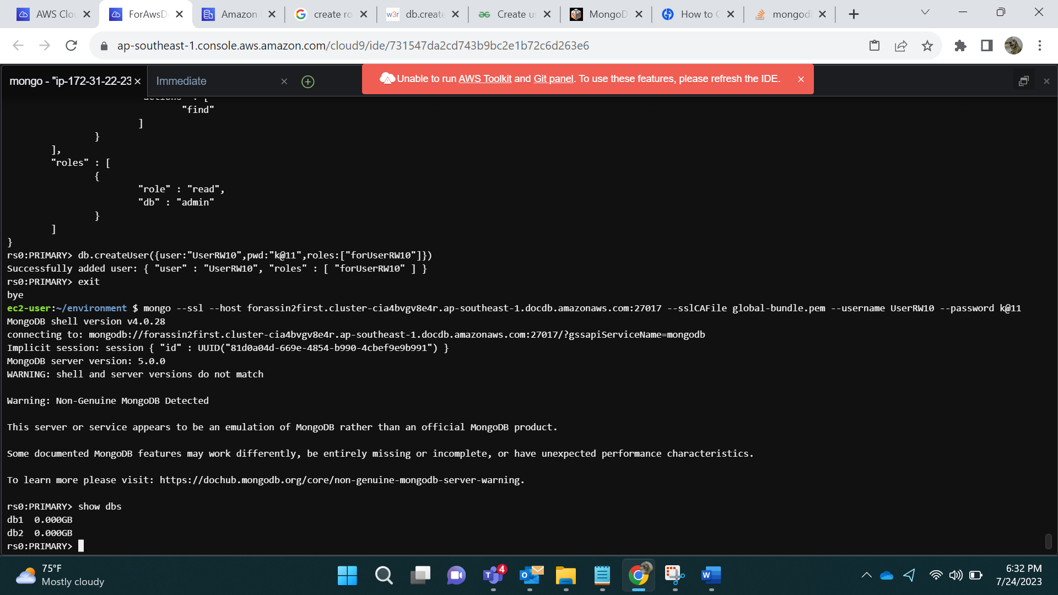

- **Grant additional privileges to a user defined role**

For this I am initially creating a Role and assigning it to a user:

db.createRole(

{

role: "forUserRW11",

privileges:[{resource:{db:"",collection:""},actions:["find"]}],

roles:[{role: "read",db:"admin"}]

})

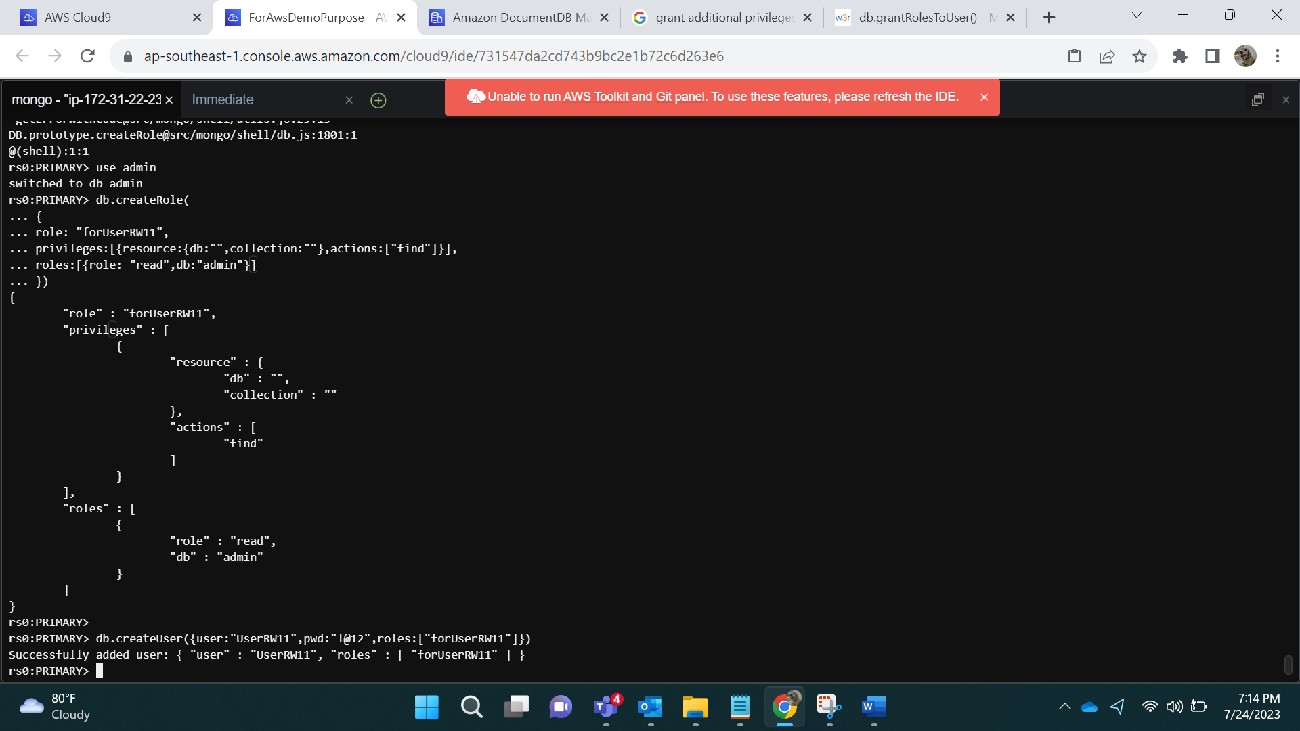

**Granting additional Privileges to User:**

db.grantPrivilegesToRole(

"forUserRW11",

[

{

resource: { db: "", collection: "" },

actions: ["find", "update", "insert"]

}

])

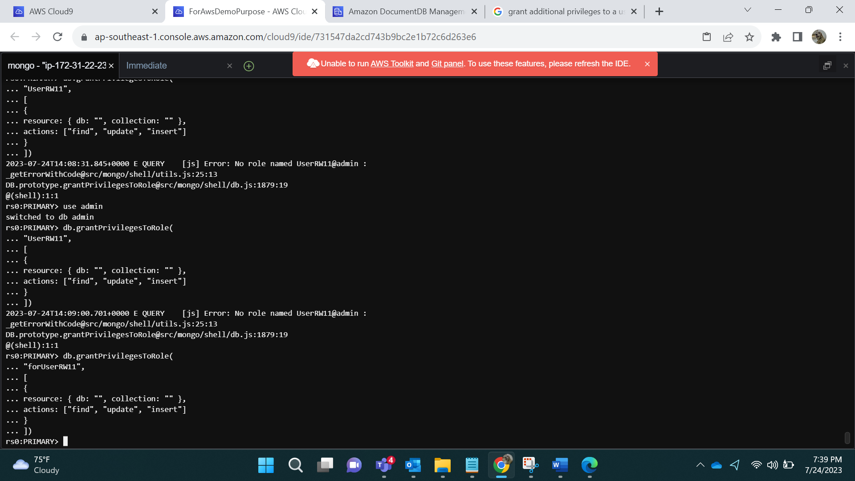

Output:

mongo --ssl --host forassin2first.cluster-cia4bvgv8e4r.ap-southeast-1.docdb.amazonaws.com:27017 --sslCAFile global-bundle.pem --username UserRW11 --password l@12

db.table8.update(

{_id:2},

{$set:{name:"Stella"}}

)

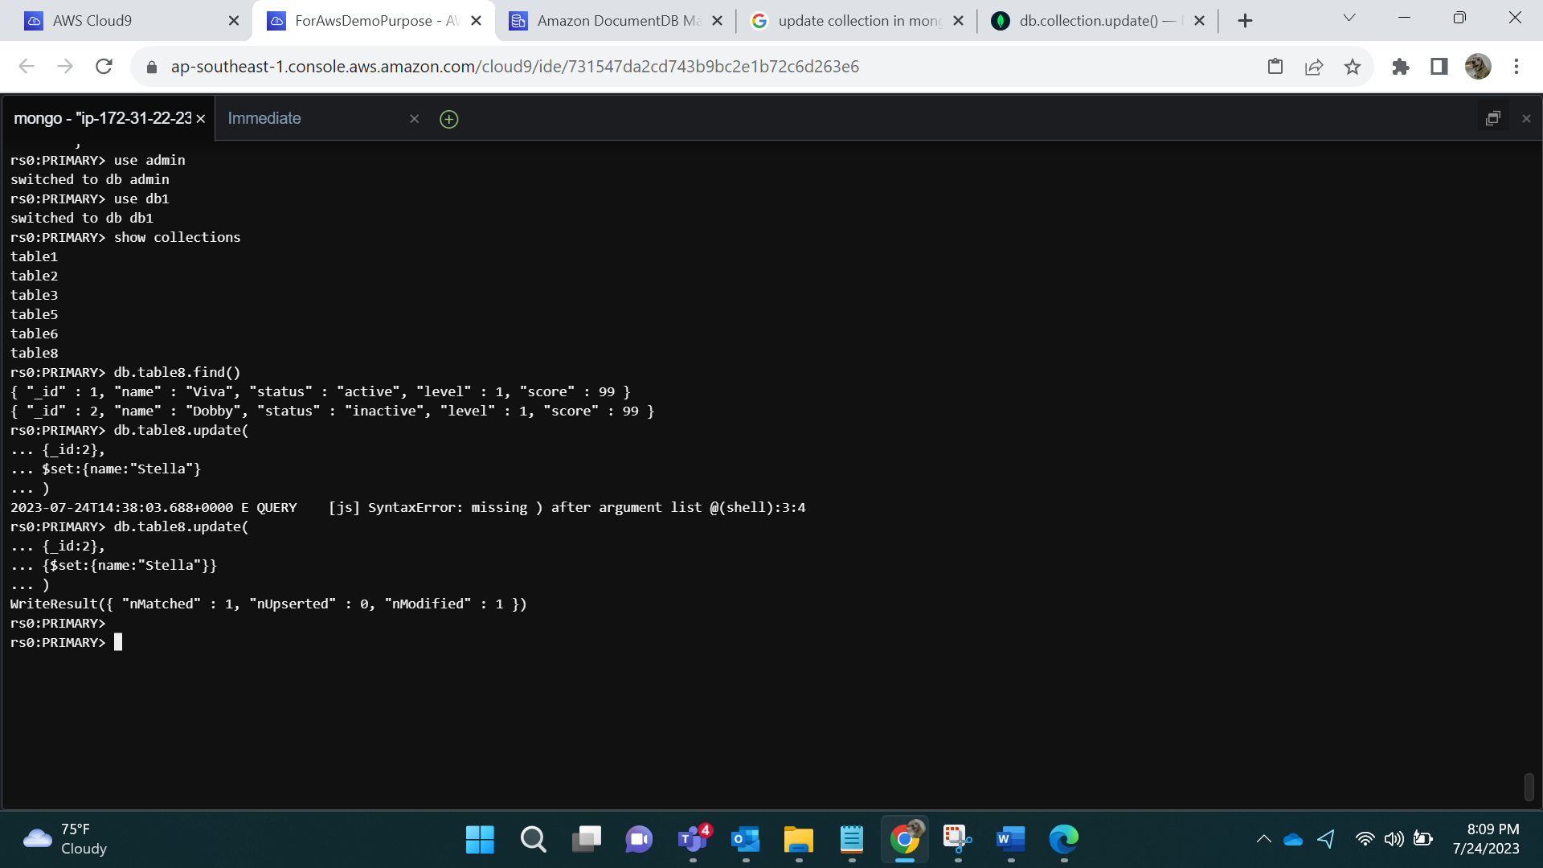

**- Revoke privileges from a user defined role**

db.revokePrivilegesFromRole(

"forUserRW10",

[

{

resource:{

db:"",collection:""

},

actions:["find"]}]

)

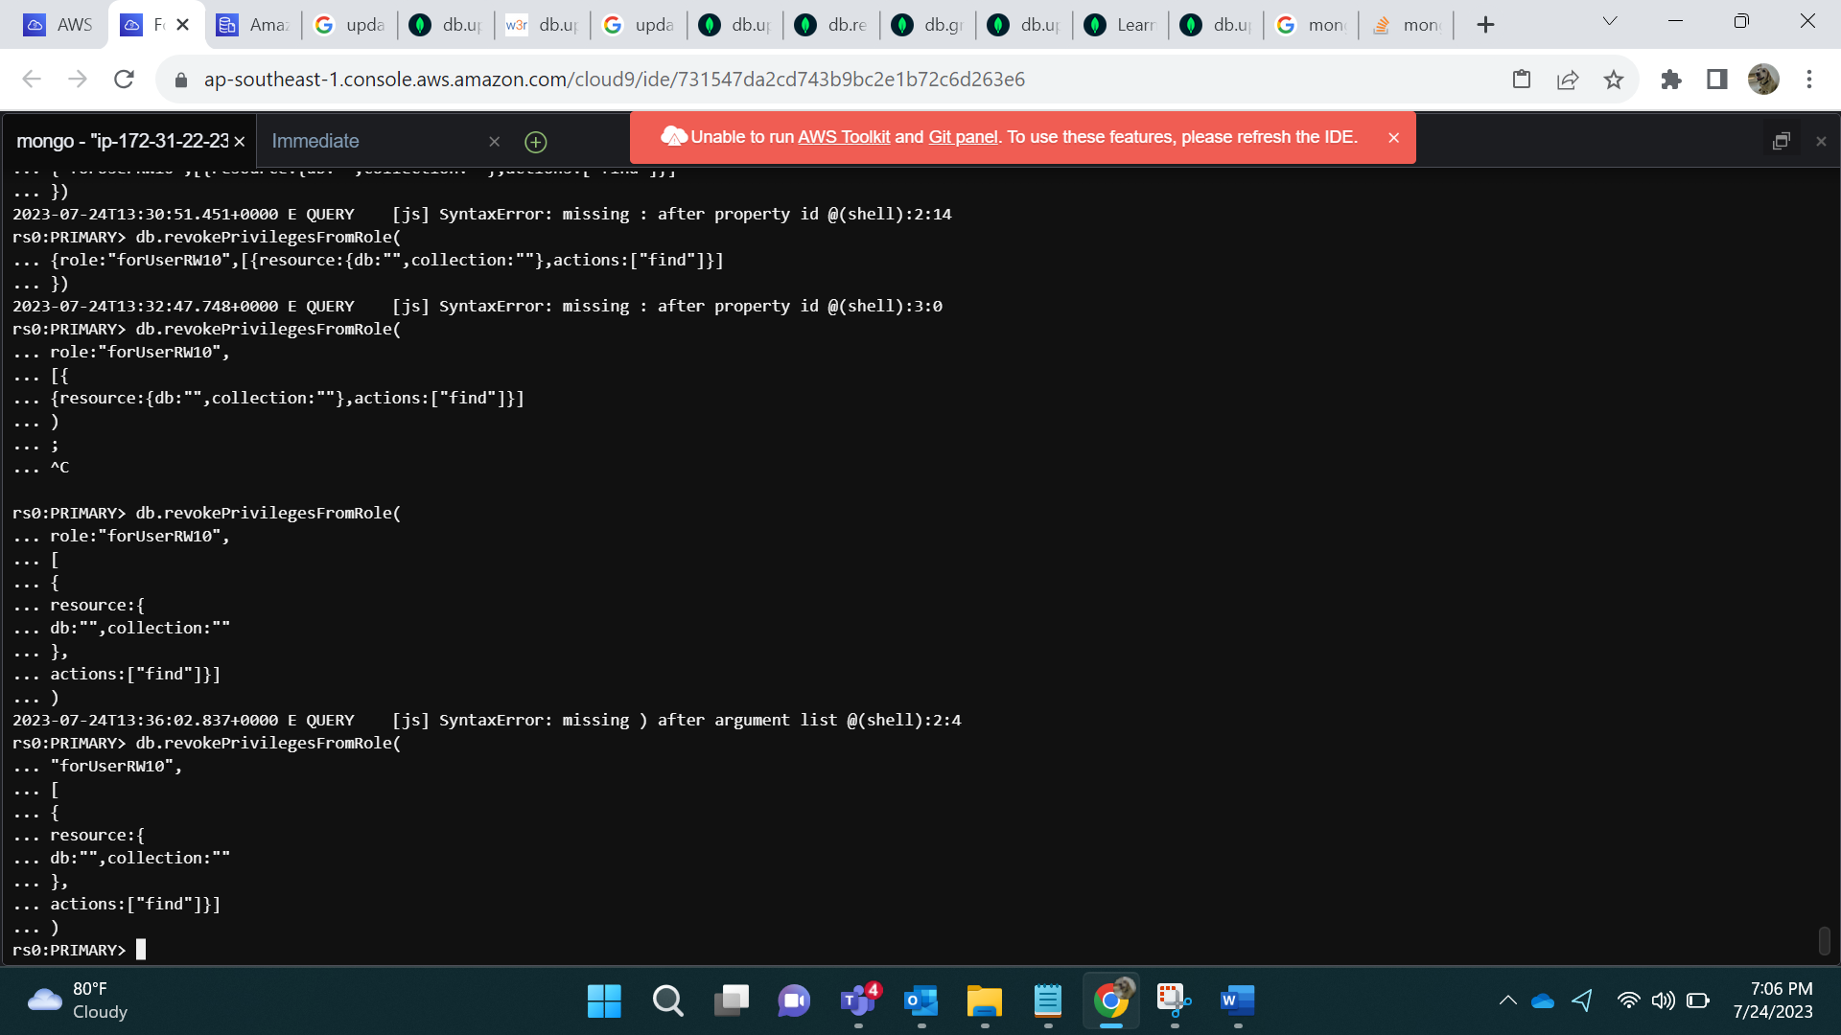

mongo --ssl --host forassin2first.cluster-cia4bvgv8e4r.ap-southeast-1.docdb.amazonaws.com:27017 --sslCAFile global-bundle.pem --username UserRW10 --password k@11

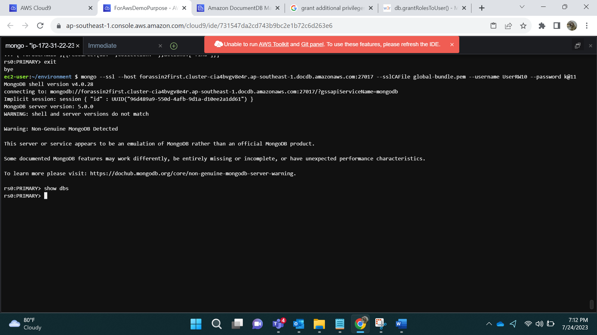

**- Update an existing user defined role**

db.updateRole(

"forUserRW11",

{

privileges: [

{

resource: {db:"", collection:""}, actions:["find", "update", "insert", "remove"]

}],

roles: []

})

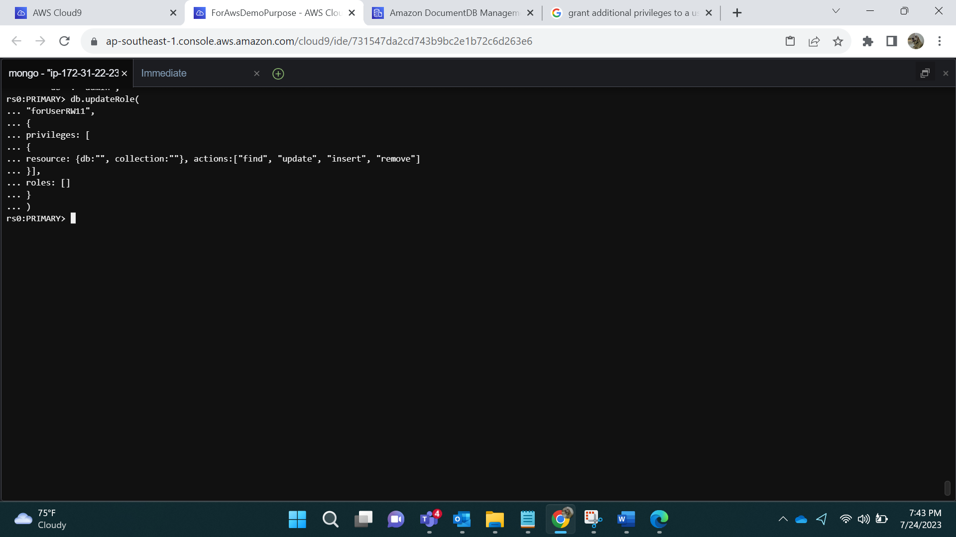

Output:

Logging in:

mongo --ssl --host forassin2first.cluster-cia4bvgv8e4r.ap-southeast-1.docdb.amazonaws.com:27017 --sslCAFile global-bundle.pem --username UserRW11 --password l@12

Insert Data :

db.table8.insertMany([

{ "_id" : 1, "name" : "Viva", "status": "active", "level": 1,"score":99},

{ "_id" : 2, "name" : "Dobby", "status": "inactive", "level": 1,"score":99}

])

